LAPORAN DOKUMETASI DAN TESTING PROGRAM
TOKO BERKAH JAYA



Penulis:
Revaldi Winata
NIM: 231011401910

PROGRAM STUDI TEKNIK INFORMATIKA
FAKULTAS ILMU KOMPUTER
UNIVERSITAS PAMULANG
TAHUN 2026

DOKUMENTASI PROGRAM DAN TESTING

BAB I. Pendahuluan
- Latar Belakang dan Tujuan Pembuatan Dokumen
- Latar Belakang
Perkembangan teknologi digital mendorong pelaku usaha, termasuk sektor retail dan Usaha Mikro, Kecil, dan Menengah (UMKM) seperti Toko Berkah Jaya, untuk meningkatkan efisiensi dalam menjalankan operasional sehari-hari. Pengelolaan transaksi penjualan serta pencatatan persediaan yang masih dilakukan secara manual sering menimbulkan berbagai kendala, mulai dari kesalahan pencatatan akibat faktor manusia, proses pencarian data yang kurang efisien, kesulitan memantau stok barang secara langsung, hingga penyusunan laporan penjualan yang membutuhkan waktu relatif lama.
Sebagai solusi atas permasalahan tersebut, dikembangkan Aplikasi Kasir (Point of Sales/POS) Toko Berkah Jaya berbasis desktop menggunakan bahasa pemrograman Java dengan antarmuka Java Swing serta sistem basis data relasional MySQL. Aplikasi ini dirancang untuk mempercepat proses transaksi, mengurangi kesalahan perhitungan pada kasir, melakukan pembaruan stok secara otomatis, serta menghasilkan laporan penjualan yang akurat dan mudah diakses.
- Tujuan Pembuatan Dokumen
Dokumen Dokumentasi Program dan Testing disusun untuk mencapai beberapa tujuan berikut:
- Panduan Teknis Sistem
Menyediakan dokumentasi yang terstruktur mengenai arsitektur aplikasi, rancangan basis data, dan implementasi kode sumber sehingga proses pengembangan maupun pemeliharaan sistem pada masa mendatang dapat dilakukan dengan lebih mudah.
- Penjaminan Mutu (Quality Assurance)
Mendokumentasikan rencana serta hasil pengujian menggunakan metode Black-Box Testing (Alpha Test) guna memastikan setiap fungsi aplikasi bekerja sesuai kebutuhan dan tidak mengalami kesalahan operasional.
- Dokumentasi Akademik
Memenuhi persyaratan penyusunan laporan proyek pada mata kuliah Pemrograman II Program Studi Teknik Informatika Universitas Pamulang.

- Deskripsi Umum Sistem
Aplikasi Kasir Toko Berkah Jaya merupakan sistem Point of Sales berbasis Java Desktop yang dikembangkan untuk mendukung aktivitas transaksi harian secara terkomputerisasi. Sistem dibangun dengan arsitektur modular yang memisahkan komponen antarmuka pengguna (Graphical User Interface/GUI), model data, dan layanan akses basis data (Service Layer) agar pengelolaan aplikasi menjadi lebih terstruktur.
Fitur utama yang tersedia pada aplikasi meliputi:
- Sistem Login Multi-user
Mengatur hak akses berdasarkan peran pengguna. Admin memiliki wewenang penuh terhadap pengelolaan data master, laporan, dan log aktivitas, sedangkan kasir hanya diberikan akses pada proses transaksi penjualan.
- Manajemen Data Master (CRUD)
Menyediakan fasilitas pengelolaan data Barang, termasuk informasi stok minimum, Kategori Barang, Customer, dan User melalui operasi Create, Read, Update, dan Delete.
- Transaksi Penjualan
Menyediakan keranjang belanja interaktif dengan perhitungan subtotal otomatis, pencarian barang secara cepat, perhitungan uang kembalian, pencetakan struk transaksi, serta pratinjau invoice dalam format PDF.
- Log Transaksi
Mencatat setiap aktivitas pengguna beserta perubahan stok barang sehingga riwayat transaksi dapat ditelusuri dengan baik.
- Dashboard Summary
Menampilkan ringkasan informasi penting, seperti total pendapatan harian, produk terlaris, pelanggan dengan transaksi terbanyak, serta kondisi stok yang telah mencapai batas minimum.
- Laporan Penjualan dan Ekspor Data
Menyediakan laporan penjualan berdasarkan rentang tanggal, pelanggan, maupun kategori barang. Data laporan juga dapat diekspor ke dalam format Microsoft Excel (.xlsx) menggunakan pustaka Apache POI.

- Deskripsi Dokumen (Ikhtisar)
Dokumen ini disusun ke dalam 4 (empat) bagian utama sebagai berikut:
- BAB I. Pendahuluan
Bab ini menguraikan dasar pengembangan perangkat lunak, tujuan penyusunan dokumen, gambaran umum mengenai sistem yang dibangun, istilah dan singkatan yang digunakan, serta referensi yang menjadi landasan dalam penyusunan laporan.
- BAB II. Dokumentasi Program
Bab ini memuat dokumentasi teknis aplikasi yang mencakup perangkat lunak pendukung pengembangan, spesifikasi perangkat keras, rancangan relasi basis data, implementasi struktur tabel, dokumentasi kode sumber pada modul utama, serta komponen eksternal (pre-existing components) yang dimanfaatkan selama proses pembangunan sistem.
- BAB III. Lingkungan Pengujian Perangkat Lunak
Bab ini menjelaskan lingkungan yang digunakan selama proses pengujian, perencanaan pengujian fungsional dengan metode Black-box Testing, skenario pengujian yang diterapkan, serta hasil implementasi pengujian untuk memverifikasi bahwa setiap fitur aplikasi telah berfungsi sesuai dengan kebutuhan.
- BAB IV. Penutup
Bab terakhir menyajikan kesimpulan yang diperoleh dari keseluruhan tahapan analisis, perancangan, implementasi, dan pengujian aplikasi. Selain itu, disampaikan pula beberapa saran yang dapat dijadikan acuan dalam pengembangan maupun penyempurnaan sistem pada versi berikutnya.

- Definisi dan Singkatan
Istilah dan singkatan yang digunakan dalam dokumen ini dijelaskan sebagai berikut:
- POS (Point of Sales) merupakan sistem kasir berbasis komputer yang digunakan untuk mengelola transaksi penjualan.
- JDK (Java Development Kit) adalah perangkat lunak yang digunakan untuk mengompilasi dan menjalankan aplikasi Java.
- IDE (Integrated Development Environment) merupakan lingkungan pengembangan yang digunakan untuk menulis, mengelola, dan mengompilasi kode program. Pada proyek ini digunakan Apache NetBeans.
- RDBMS (Relational Database Management System) adalah sistem manajemen basis data relasional yang pada aplikasi ini diimplementasikan menggunakan MySQL.
- CRUD (Create, Read, Update, Delete) merupakan empat operasi dasar yang digunakan dalam pengelolaan data, yaitu menambah, membaca, mengubah, dan menghapus data.
- FlatLaf (Flat Look and Feel) adalah pustaka Java Swing yang digunakan untuk menghasilkan tampilan antarmuka yang modern, sederhana, serta mendukung tema gelap (dark mode).
- Apache POI merupakan library Java yang digunakan untuk membaca dan menghasilkan dokumen Microsoft Office, khususnya berkas Microsoft Excel (.xlsx).
- Black-Box Testing adalah metode pengujian perangkat lunak yang mengevaluasi kesesuaian fungsi berdasarkan masukan dan keluaran sistem tanpa meninjau implementasi kode program.

- Dokumen Referensi
Dokumen ini mengacu pada beberapa sumber berikut:
- Mentari (e-Learning) Pemrograman II, Program Studi Teknik Informatika, Fakultas Ilmu Komputer, Universitas Pamulang.
- Java SE 11 Documentation, Oracle Corporation. URL: https://docs.oracle.com/en/java/javase/11/
- MySQL Reference Manual, Oracle Corporation. URL: https://dev.mysql.com/doc/
- FlatLaf - Flat Look and Feel Documentation, FormDev Software GmbH. URL: https://www.formdev.com/flatlaf/
- Apache POI API Documentation, The Apache Software Foundation. URL: https://poi.apache.org/

BAB II. Dokumentasi Program
- Perangkat Lunak Pembangun
Perangkat lunak yang digunakan pada sistem komputer yang digunakan untuk membangun Aplikasi Untuk Sistem Toko Berkah Jaya adalah sebagai berikut:
Tabel 1
Spesifikasi perangkat lunak

No | Perangkat Lunak | Keterangan
1. | Sistem Operasi | Windows 10
2. | Web browser | Google Chrome
3. | Code programmer | Apache NetBeans IDE 25
4. | database | MySQL, XAMPP Server

- Perangkat Keras
Kebutuhan minimum perangkat keras (hardware) yang diperlukan untuk mengimplementasikan program aplikasi yang dibuat adalah perangkat keras komputer PC kompatibel dengan spesifikasi yang disebutkan dibawah ini.
Semakin tinggi spesifikasi komputer yang digunakan untuk menjalankan aplikasi, akan semakin baik. Adapun spesifikasi perangkat keras yang digunakan untuk membangun aplikasi sistem Toko Berkah Jaya ini adalah sebagai berikut :
Tabel 2
Spesifikasi perangkat keras
No | Perangkat Keras | Spesifikasi
1. | Prosessor | Intel Core i3 / AMD Ryzen 3 (atau setara Dual-Core 2.4 GHz ke atas)
2. | Monitor | Monitor LCD / LED 15 inch ke atas (Resolusi minimal 1366x768)
3. | VGA | Intel HD Graphics / On-Board VGA 512 Mb
4. | Memori | RAM 4 Gb (DDR3 / DDR4)
5. | Hard disk | SSD dengan kapasitas bebas minimal 10 Gb (untuk Windows, JDK, MySQL, & DB)
6. | Optical Drive | Tidak diperlukan (Opsional)
7. | Keyboard | Standard
8. | Mouse | Standard
9. | Printer | Thermal Receipt Printer 58mm / 80mm USB

- Skema Basis Data
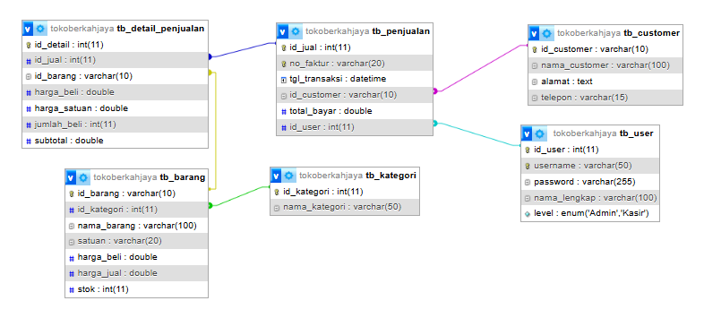

Gambar 1
Skema Relasi Basis data

- Implementasi Basis Data
-- 1. Membuat Database
CREATE DATABASE IF NOT EXISTS `tokoberkahjaya`;
USE `tokoberkahjaya`;

-- 2. Membuat Tabel User
CREATE TABLE `tb_user` (
`id_user` int(11) NOT NULL AUTO_INCREMENT,
`username` varchar(50) NOT NULL,
`password` varchar(255) NOT NULL,
`nama_lengkap` varchar(100) NOT NULL,
`level` enum('Admin','Kasir') NOT NULL,
PRIMARY KEY (`id_user`),
UNIQUE KEY `username` (`username`)
) ENGINE=InnoDB DEFAULT CHARSET=utf8mb4;

-- 3. Membuat Tabel Kategori
CREATE TABLE `tb_kategori` (
`id_kategori` int(11) NOT NULL AUTO_INCREMENT,
`nama_kategori` varchar(50) NOT NULL,
PRIMARY KEY (`id_kategori`)
) ENGINE=InnoDB DEFAULT CHARSET=utf8mb4;

-- 4. Membuat Tabel Barang
CREATE TABLE `tb_barang` (
`id_barang` varchar(10) NOT NULL,
`id_kategori` int(11) DEFAULT NULL,
`nama_barang` varchar(100) NOT NULL,
`satuan` varchar(20) DEFAULT NULL,
`harga_jual` double NOT NULL,
`stok` int(11) NOT NULL,
PRIMARY KEY (`id_barang`),
KEY `id_kategori` (`id_kategori`),
CONSTRAINT `tb_barang_ibfk_1` FOREIGN KEY (`id_kategori`)
REFERENCES `tb_kategori` (`id_kategori`)
) ENGINE=InnoDB DEFAULT CHARSET=utf8mb4;

-- 5. Membuat Tabel Customer
CREATE TABLE `tb_customer` (
`id_customer` varchar(10) NOT NULL,
`nama_customer` varchar(100) NOT NULL,
`alamat` text DEFAULT NULL,
`telepon` varchar(15) DEFAULT NULL,
PRIMARY KEY (`id_customer`)
) ENGINE=InnoDB DEFAULT CHARSET=utf8mb4;

-- 6. Membuat Tabel Penjualan (Header Transaksi)
CREATE TABLE `tb_penjualan` (
`id_jual` int(11) NOT NULL AUTO_INCREMENT,
`no_faktur` varchar(20) NOT NULL,
`tgl_transaksi` date NOT NULL,
`id_customer` varchar(10) DEFAULT NULL,
`total_bayar` double NOT NULL,
`id_user` int(11) DEFAULT NULL,
PRIMARY KEY (`id_jual`),
UNIQUE KEY `no_faktur` (`no_faktur`),
KEY `id_customer` (`id_customer`),
KEY `id_user` (`id_user`),
CONSTRAINT `tb_penjualan_ibfk_1` FOREIGN KEY (`id_customer`)
REFERENCES `tb_customer` (`id_customer`),
CONSTRAINT `tb_penjualan_ibfk_2` FOREIGN KEY (`id_user`)
REFERENCES `tb_user` (`id_user`)
) ENGINE=InnoDB DEFAULT CHARSET=utf8mb4;

-- 7. Membuat Tabel Detail Penjualan (Item Belanja)
CREATE TABLE `tb_detail_penjualan` (
`id_detail` int(11) NOT NULL AUTO_INCREMENT,
`id_jual` int(11) NOT NULL,
`id_barang` varchar(10) NOT NULL,
`harga_satuan` double NOT NULL,
`jumlah_beli` int(11) NOT NULL,
`subtotal` double NOT NULL,
PRIMARY KEY (`id_detail`),
KEY `id_jual` (`id_jual`),
KEY `id_barang` (`id_barang`),
CONSTRAINT `tb_detail_penjualan_ibfk_1` FOREIGN KEY (`id_jual`)
REFERENCES `tb_penjualan` (`id_jual`),
CONSTRAINT `tb_detail_penjualan_ibfk_2` FOREIGN KEY (`id_barang`)
REFERENCES `tb_barang` (`id_barang`)
) ENGINE=InnoDB DEFAULT CHARSET=utf8mb4;

- Dokumentasi Kode Sumber
Nama Modul : Form LoginForm
Deskripsi : Form antarmuka untuk autentikasi hak akses pengguna (Admin dan Kasir) ke dalam sistem.
package ui;

import model.User;
import service.UserService;
import ui.components.Toast;

import javax.swing.*;
import javax.swing.border.EmptyBorder;
import util.ThemeUtil;
import util.ValidationUtil;
import ui.components.RoundedPanel;
import java.awt.*;
import java.awt.event.ActionEvent;
import java.awt.event.ActionListener;

public class LoginForm extends JFrame {

private JTextField txtUsername;
private JPasswordField txtPassword;
private JButton btnLogin;

private UserService userService;

public LoginForm() {

userService = new UserService();

setTitle("Login - Toko Berkah Jaya");
setSize(800, 500);
setDefaultCloseOperation(JFrame.EXIT_ON_CLOSE);
setLocationRelativeTo(null);
getContentPane().setBackground(ThemeUtil.BG_SOFT);

ImageIcon logoIcon = ThemeUtil.getScaledImage("/images/logo.png", 64, 64);
if (logoIcon != null) {
setIconImage(logoIcon.getImage());
}

initComponents();
}

private void initComponents() {

Container container = getContentPane();
container.setLayout(new GridBagLayout());

RoundedPanel loginCard = ThemeUtil.createCardPanel();
loginCard.setPreferredSize(new Dimension(400, 480));
loginCard.setLayout(new BoxLayout(loginCard, BoxLayout.Y_AXIS));

JLabel lblLogo = new JLabel();
ImageIcon bigLogo = ThemeUtil.getScaledImage("/images/logo.png", 80, 80);
if (bigLogo != null) lblLogo.setIcon(bigLogo);
lblLogo.setAlignmentX(Component.CENTER_ALIGNMENT);

JLabel lblTitle = new JLabel("Toko Berkah Jaya");
lblTitle.setFont(new Font("Segoe UI", Font.BOLD, 28));
lblTitle.setForeground(ThemeUtil.OCEAN_BLUE);
lblTitle.setAlignmentX(Component.CENTER_ALIGNMENT);

JLabel lblSub = new JLabel("Silakan Login ke Akun Anda");
lblSub.setFont(ThemeUtil.FONT_REGULAR);
lblSub.setForeground(ThemeUtil.TEXT_SECONDARY);
lblSub.setAlignmentX(Component.CENTER_ALIGNMENT);

JPanel panelUser = new JPanel(new BorderLayout(5, 5));
panelUser.setOpaque(false);
panelUser.setMaximumSize(new Dimension(300, 60));

JLabel lblUser = new JLabel("Username");
lblUser.setFont(ThemeUtil.FONT_REGULAR);
lblUser.setForeground(ThemeUtil.TEXT_SECONDARY);

txtUsername = new JTextField();
ThemeUtil.styleTextField(txtUsername);
ValidationUtil.addRequiredValidation(txtUsername);

panelUser.add(lblUser, BorderLayout.NORTH);
panelUser.add(txtUsername, BorderLayout.CENTER);

JPanel panelPass = new JPanel(new BorderLayout(5, 5));
panelPass.setOpaque(false);
panelPass.setMaximumSize(new Dimension(300, 60));

JLabel lblPass = new JLabel("Password");
lblPass.setFont(ThemeUtil.FONT_REGULAR);
lblPass.setForeground(ThemeUtil.TEXT_SECONDARY);

txtPassword = new JPasswordField();
ThemeUtil.stylePasswordField(txtPassword);
ValidationUtil.addRequiredValidation(txtPassword);

panelPass.add(lblPass, BorderLayout.NORTH);
panelPass.add(txtPassword, BorderLayout.CENTER);

btnLogin = new JButton("LOGIN");
ThemeUtil.styleButton(btnLogin, ThemeUtil.OCEAN_BLUE);
btnLogin.setMaximumSize(new Dimension(300, 45));
btnLogin.setAlignmentX(Component.CENTER_ALIGNMENT);

loginCard.add(Box.createRigidArea(new Dimension(0, 10)));
loginCard.add(lblLogo);
loginCard.add(Box.createRigidArea(new Dimension(0, 10)));
loginCard.add(lblTitle);
loginCard.add(Box.createRigidArea(new Dimension(0, 5)));
loginCard.add(lblSub);
loginCard.add(Box.createRigidArea(new Dimension(0, 30)));
loginCard.add(panelUser);
loginCard.add(Box.createRigidArea(new Dimension(0, 15)));
loginCard.add(panelPass);
loginCard.add(Box.createRigidArea(new Dimension(0, 30)));
loginCard.add(btnLogin);
loginCard.add(Box.createRigidArea(new Dimension(0, 20)));

container.add(loginCard);

btnLogin.addActionListener(e -> doLogin());

txtUsername.addActionListener(e -> txtPassword.requestFocus());

txtPassword.addActionListener(e -> btnLogin.doClick());

getRootPane().setDefaultButton(btnLogin);
}

private void doLogin() {

String username = txtUsername.getText();
String password = new String(txtPassword.getPassword());

if (username.isEmpty() || password.isEmpty()) {
Toast.showError(this, "Username dan Password tidak boleh kosong!");
return;
}

User user = userService.login(username, password);

if (user != null) {

Toast.showSuccess(this, "Login Berhasil! Selamat Datang " + user.getNamaLengkap());

SwingUtilities.invokeLater(() -> {
MenuUtama menu = new MenuUtama(user);
menu.setVisible(true);
dispose();
});
} else {

Toast.showError(this, "Username atau Password salah!");
}
}
}
Hasil:

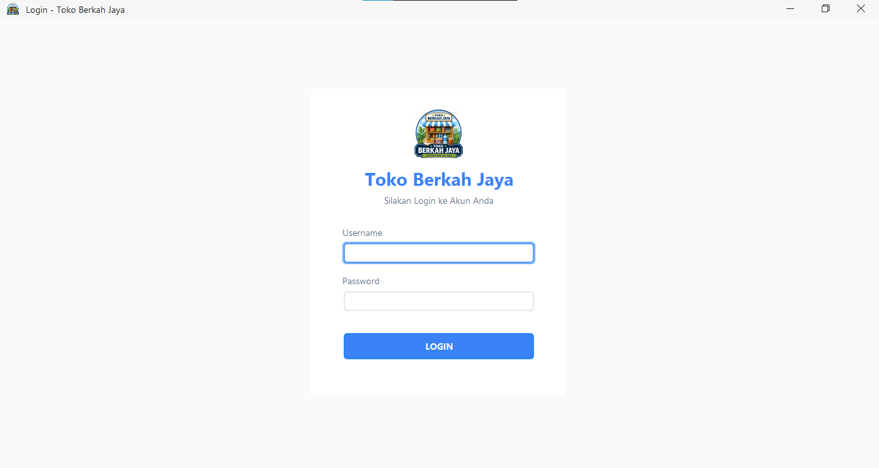

Nama Modul : Form MenuUtama
Deskripsi : Form utama aplikasi kasir yang berfungsi sebagai kontainer navigasi dan mengelola pemisahan hak akses menu utama.
package ui;

import model.User;
import ui.components.Toast;
import javax.swing.*;
import javax.swing.border.EmptyBorder;
import javax.swing.border.MatteBorder;
import util.ThemeUtil;
import java.awt.*;
import com.formdev.flatlaf.extras.FlatSVGIcon;
import java.awt.event.MouseAdapter;
import java.awt.event.MouseEvent;
import java.util.ArrayList;

public class MenuUtama extends JFrame {

private User loggedInUser;

private JPanel mainContent;

private CardLayout cardLayout;

private DashboardForm dashboardForm;
private KategoriForm kategoriForm;
private BarangForm barangForm;
private CustomerForm customerForm;
private PenjualanForm penjualanForm;
private LogTransaksiForm logTransaksiForm;
private UserForm userForm;
private ProfilForm profilForm;
private LaporanForm laporanForm;

private JLabel lblTopTitle;
private JButton btnUserDropdown;
private java.util.List<JButton> sidebarButtons = new ArrayList<>();

public MenuUtama(User user) {
this.loggedInUser = user;

setTitle("Toko Berkah Jaya - Dashboard");
setSize(1100, 750);
setDefaultCloseOperation(JFrame.EXIT_ON_CLOSE);
setLocationRelativeTo(null);

ImageIcon logoIcon = ThemeUtil.getScaledImage("/images/logo.png", 64, 64);
if (logoIcon != null) {
setIconImage(logoIcon.getImage());
}

initComponents();
}

private void initComponents() {
Container mainContainer = getContentPane();
mainContainer.setLayout(new BorderLayout());

JPanel sideBar = new JPanel();
sideBar.setLayout(new BoxLayout(sideBar, BoxLayout.Y_AXIS));
sideBar.setBackground(ThemeUtil.OCEAN_BLUE);
sideBar.setPreferredSize(new Dimension(260, getHeight()));

JPanel logoPanel = new JPanel(new FlowLayout(FlowLayout.LEFT, 15, 15));
logoPanel.setOpaque(false);
logoPanel.setAlignmentX(Component.LEFT_ALIGNMENT);
logoPanel.setMaximumSize(new Dimension(Integer.MAX_VALUE, 70));
logoPanel.setPreferredSize(new Dimension(260, 70));
logoPanel.setBorder(new MatteBorder(0, 0, 1, 0, new Color(255, 255, 255, 60)));

JLabel lblSidebarLogo = new JLabel();
ImageIcon logoIconSmall = ThemeUtil.getScaledImage("/images/logo.png", 40, 40);
if (logoIconSmall != null) {
lblSidebarLogo.setIcon(logoIconSmall);
}

JLabel lblSidebarTitle = new JLabel("Toko Berkah Jaya");
lblSidebarTitle.setFont(new Font("Segoe UI", Font.BOLD, 16));
lblSidebarTitle.setForeground(Color.WHITE);

logoPanel.add(lblSidebarLogo);
logoPanel.add(lblSidebarTitle);

sideBar.add(logoPanel);
sideBar.add(Box.createRigidArea(new Dimension(0, 10)));

JLabel lblMenuMaster = createMenuHeader("MAIN MENU");
JButton btnDashboard = createSidebarButton("Dashboard", "layout-dashboard");
JButton btnKategori = createSidebarButton("Kelola Kategori", "tags");
JButton btnBarang = createSidebarButton("Kelola Barang", "package");
JButton btnCustomer = createSidebarButton("Kelola Customer", "users");

JLabel lblMenuTransaksi = createMenuHeader("TRANSAKSI");
JButton btnPenjualan = createSidebarButton("Kasir / Penjualan", "shopping-cart");
JButton btnLogTransaksi = createSidebarButton("Log Transaksi", "file-text");

sideBar.add(btnDashboard);
sideBar.add(Box.createRigidArea(new Dimension(0, 20)));
sideBar.add(lblMenuMaster);
sideBar.add(Box.createRigidArea(new Dimension(0, 10)));
sideBar.add(btnKategori);
sideBar.add(btnBarang);
sideBar.add(btnCustomer);

sideBar.add(Box.createRigidArea(new Dimension(0, 30)));

sideBar.add(lblMenuTransaksi);
sideBar.add(Box.createRigidArea(new Dimension(0, 10)));
sideBar.add(btnPenjualan);
sideBar.add(btnLogTransaksi);

JButton btnLaporan = createSidebarButton("Laporan Penjualan", "file-text");
sideBar.add(btnLaporan);

JLabel lblMenuPengaturan = createMenuHeader("PENGATURAN");
JButton btnKelolaUser = createSidebarButton("Kelola User", "user");

sideBar.add(Box.createRigidArea(new Dimension(0, 30)));
sideBar.add(lblMenuPengaturan);
sideBar.add(Box.createRigidArea(new Dimension(0, 10)));
sideBar.add(btnKelolaUser);

JPanel contentWrapper = new JPanel(new BorderLayout());

JPanel topBar = new JPanel(new BorderLayout());
topBar.setBackground(ThemeUtil.BG_WHITE);
topBar.setPreferredSize(new Dimension(getWidth(), 70));
topBar.setBorder(BorderFactory.createCompoundBorder(
new MatteBorder(0, 0, 1, 0, ThemeUtil.BORDER_COLOR),
new EmptyBorder(10, 25, 10, 25)
));

lblTopTitle = new JLabel("Ringkasan Dashboard");
lblTopTitle.setFont(new Font("Segoe UI", Font.BOLD, 22));
lblTopTitle.setForeground(ThemeUtil.OCEAN_BLUE);
topBar.add(lblTopTitle, BorderLayout.WEST);

JPanel userPanel = new JPanel(new FlowLayout(FlowLayout.RIGHT, 10, 5));
userPanel.setOpaque(false);

btnUserDropdown = new JButton("Halo, " + loggedInUser.getNamaLengkap() + " (" + loggedInUser.getLevel() + ") \u25BC");
btnUserDropdown.setFont(new Font("Segoe UI", Font.BOLD, 14));
btnUserDropdown.setForeground(ThemeUtil.TEXT_PRIMARY);
btnUserDropdown.setContentAreaFilled(false);
btnUserDropdown.setBorderPainted(false);
btnUserDropdown.setCursor(new Cursor(Cursor.HAND_CURSOR));

try {
com.formdev.flatlaf.extras.FlatSVGIcon userIcon = new com.formdev.flatlaf.extras.FlatSVGIcon("icons/circle-user-round.svg", 28, 28);
userIcon.setColorFilter(new com.formdev.flatlaf.extras.FlatSVGIcon.ColorFilter(color -> ThemeUtil.OCEAN_BLUE));
btnUserDropdown.setIcon(userIcon);
btnUserDropdown.setIconTextGap(10);
} catch (Exception e) {}

JPopupMenu userMenu = new JPopupMenu();
userMenu.setBackground(Color.WHITE);
userMenu.setBorder(BorderFactory.createCompoundBorder(
BorderFactory.createLineBorder(ThemeUtil.BORDER_COLOR, 1),
new EmptyBorder(5, 0, 5, 0)
));

JMenuItem itemProfil = createDropdownItem("Profil Saya", ThemeUtil.TEXT_PRIMARY);
itemProfil.addActionListener(e -> {
setActiveButton(null);
lblTopTitle.setText("Profil Pengguna");
cardLayout.show(mainContent, "PROFIL");
});

JMenuItem itemTentang = createDropdownItem("Tentang Aplikasi", ThemeUtil.TEXT_PRIMARY);
itemTentang.addActionListener(e -> showAboutDialog());

JMenuItem itemLogout = createDropdownItem("Logout", ThemeUtil.ERROR_COLOR);
itemLogout.addActionListener(e -> {
new LoginForm().setVisible(true);
dispose();
});

userMenu.add(itemProfil);
userMenu.add(itemTentang);

JSeparator sep = new JSeparator();
sep.setForeground(ThemeUtil.BORDER_COLOR);
userMenu.add(sep);

userMenu.add(itemLogout);

btnUserDropdown.addActionListener(e -> {

int rightPadding = btnUserDropdown.getInsets().right;
int x = btnUserDropdown.getWidth() - userMenu.getPreferredSize().width - rightPadding;
int y = btnUserDropdown.getHeight() + 5;
userMenu.show(btnUserDropdown, x, y);
});

userPanel.add(btnUserDropdown);
topBar.add(userPanel, BorderLayout.EAST);
contentWrapper.add(topBar, BorderLayout.NORTH);

cardLayout = new CardLayout();
mainContent = new JPanel(cardLayout) {
@Override
public Dimension getPreferredSize() {
Dimension pref = super.getPreferredSize();
Container parent = getParent();
if (parent instanceof JViewport) {
Dimension viewSize = ((JViewport) parent).getSize();
pref.width = Math.max(pref.width, viewSize.width);
pref.height = Math.max(pref.height, viewSize.height);
}
return pref;
}
};
mainContent.setBackground(ThemeUtil.BG_SOFT);

dashboardForm = new DashboardForm(() -> btnLogTransaksi.doClick());
kategoriForm = new KategoriForm();
barangForm = new BarangForm();
customerForm = new CustomerForm();
penjualanForm = new PenjualanForm(loggedInUser);
logTransaksiForm = new LogTransaksiForm();
userForm = new UserForm();
laporanForm = new LaporanForm();
profilForm = new ProfilForm(loggedInUser, () -> {

btnUserDropdown.setText("Halo, " + loggedInUser.getNamaLengkap() + " (" + loggedInUser.getLevel() + ") \u25BC");
});

mainContent.add(dashboardForm, "DASHBOARD");
mainContent.add(kategoriForm, "KATEGORI");
mainContent.add(barangForm, "BARANG");
mainContent.add(customerForm, "CUSTOMER");
mainContent.add(penjualanForm, "PENJUALAN");
mainContent.add(logTransaksiForm, "LOG");
mainContent.add(userForm, "USER");
mainContent.add(laporanForm, "LAPORAN");
mainContent.add(profilForm, "PROFIL");

JScrollPane mainScroll = new JScrollPane(mainContent);
mainScroll.setBorder(BorderFactory.createEmptyBorder());
mainScroll.getVerticalScrollBar().setUnitIncrement(16);
contentWrapper.add(mainScroll, BorderLayout.CENTER);

cardLayout.show(mainContent, "DASHBOARD");
setActiveButton(btnDashboard);

btnDashboard.addActionListener(e -> {
setActiveButton(btnDashboard);
lblTopTitle.setText("Ringkasan Dashboard");
dashboardForm.loadData();
cardLayout.show(mainContent, "DASHBOARD");
});

btnKategori.addActionListener(e -> {
setActiveButton(btnKategori);
lblTopTitle.setText("Kelola Data Kategori");
kategoriForm.loadData();
cardLayout.show(mainContent, "KATEGORI");
});

btnBarang.addActionListener(e -> {
setActiveButton(btnBarang);
lblTopTitle.setText("Kelola Data Barang");
barangForm.loadComboKategori();
barangForm.loadData();
cardLayout.show(mainContent, "BARANG");
});

btnCustomer.addActionListener(e -> {
setActiveButton(btnCustomer);
lblTopTitle.setText("Kelola Data Customer");
customerForm.loadData();
cardLayout.show(mainContent, "CUSTOMER");
});

btnPenjualan.addActionListener(e -> {
setActiveButton(btnPenjualan);
lblTopTitle.setText("Kasir / Transaksi Penjualan");
penjualanForm.clearForm();
cardLayout.show(mainContent, "PENJUALAN");
});

btnLogTransaksi.addActionListener(e -> {
setActiveButton(btnLogTransaksi);
lblTopTitle.setText("Riwayat & Log Transaksi");
logTransaksiForm.loadData();
cardLayout.show(mainContent, "LOG");
});

btnLaporan.addActionListener(e -> {
setActiveButton(btnLaporan);
lblTopTitle.setText("Laporan Penjualan & Analitik");
cardLayout.show(mainContent, "LAPORAN");
});

btnKelolaUser.addActionListener(e -> {

if(!"Admin".equals(loggedInUser.getLevel())) {
Toast.showError(this, "Hanya Admin yang dapat mengakses menu ini!");
return;
}
setActiveButton(btnKelolaUser);
lblTopTitle.setText("Kelola Pengguna Aplikasi");
userForm.clear();
cardLayout.show(mainContent, "USER");
});

if (!"Admin".equalsIgnoreCase(loggedInUser.getLevel())) {
btnKategori.setVisible(false);
btnBarang.setVisible(false);
btnKelolaUser.setVisible(false);
lblMenuPengaturan.setVisible(false);
btnLaporan.setVisible(false);
}

mainContainer.add(sideBar, BorderLayout.WEST);
mainContainer.add(contentWrapper, BorderLayout.CENTER);
}

private JLabel createMenuHeader(String text) {
JLabel lbl = new JLabel(" " + text);
lbl.setForeground(new Color(207, 250, 254));
lbl.setFont(new Font("Segoe UI", Font.BOLD, 11));
lbl.setAlignmentX(Component.LEFT_ALIGNMENT);
lbl.setMaximumSize(new Dimension(Integer.MAX_VALUE, 30));
return lbl;
}

private JButton createSidebarButton(String text, String iconName) {
JButton btn = new JButton(" " + text);
try {
FlatSVGIcon svgIcon = new FlatSVGIcon("icons/" + iconName + ".svg", 20, 20);
svgIcon.setColorFilter(new FlatSVGIcon.ColorFilter(color -> Color.WHITE));
btn.setIcon(svgIcon);
} catch (Exception ex) {
System.err.println("Failed to load icon: " + iconName);
}
btn.setMaximumSize(new Dimension(Integer.MAX_VALUE, 45));
btn.setHorizontalAlignment(SwingConstants.LEFT);
btn.setAlignmentX(Component.LEFT_ALIGNMENT);
btn.setBackground(ThemeUtil.OCEAN_BLUE);
btn.setForeground(Color.WHITE);
btn.setFocusPainted(false);
btn.setBorder(BorderFactory.createEmptyBorder(0, 20, 0, 0));
btn.setFont(ThemeUtil.FONT_REGULAR);
btn.setCursor(new Cursor(Cursor.HAND_CURSOR));

sidebarButtons.add(btn);

btn.addMouseListener(new MouseAdapter() {
public void mouseEntered(MouseEvent evt) {
if(btn.isEnabled() && !btn.getName().equals("ACTIVE")) {
btn.setBackground(ThemeUtil.OCEAN_BLUE_DARK);
}
}
public void mouseExited(MouseEvent evt) {
if(btn.isEnabled() && !btn.getName().equals("ACTIVE")) {
btn.setBackground(ThemeUtil.OCEAN_BLUE);
}
}
});

btn.setName("");
return btn;
}

private JMenuItem createDropdownItem(String text, Color fgColor) {
JMenuItem item = new JMenuItem(text);
item.setFont(new Font("Segoe UI", Font.BOLD, 14));
item.setForeground(fgColor);
item.setBackground(Color.WHITE);
item.setOpaque(true);
item.setBorder(new EmptyBorder(8, 20, 8, 40));
item.setCursor(new Cursor(Cursor.HAND_CURSOR));
return item;
}

private void setActiveButton(JButton activeBtn) {
for(JButton btn : sidebarButtons) {
btn.setName("");
if(btn.isEnabled()) {
btn.setBackground(ThemeUtil.OCEAN_BLUE);
btn.setBorder(BorderFactory.createEmptyBorder(0, 20, 0, 0));
}
}
if (activeBtn != null) {
activeBtn.setName("ACTIVE");
activeBtn.setBackground(ThemeUtil.OCEAN_BLUE_DARK);
activeBtn.setBorder(BorderFactory.createCompoundBorder(
BorderFactory.createMatteBorder(0, 4, 0, 0, ThemeUtil.SKY_BLUE),
BorderFactory.createEmptyBorder(0, 16, 0, 0)
));
}
}

private void showAboutDialog() {
JDialog dialog = new JDialog(this, "Tentang Aplikasi", true);
dialog.setSize(350, 330);
dialog.setLocationRelativeTo(this);
dialog.setLayout(new BorderLayout());
dialog.getContentPane().setBackground(Color.WHITE);

JPanel mainPanel = new JPanel();
mainPanel.setLayout(new BoxLayout(mainPanel, BoxLayout.Y_AXIS));
mainPanel.setBackground(Color.WHITE);
mainPanel.setBorder(BorderFactory.createEmptyBorder(20, 20, 20, 20));

JLabel lblLogo = new JLabel();
lblLogo.setAlignmentX(Component.CENTER_ALIGNMENT);
ImageIcon logoIcon = ThemeUtil.getScaledImage("/images/logo.png", 80, 80);
if (logoIcon != null) {
lblLogo.setIcon(logoIcon);
}

JLabel lblTitle = new JLabel("Toko Berkah Jaya");
lblTitle.setFont(new Font("Segoe UI", Font.BOLD, 20));
lblTitle.setAlignmentX(Component.CENTER_ALIGNMENT);
lblTitle.setForeground(ThemeUtil.OCEAN_BLUE);

JLabel lblVersion = new JLabel("Versi 1.0.0");
lblVersion.setFont(new Font("Segoe UI", Font.PLAIN, 14));
lblVersion.setAlignmentX(Component.CENTER_ALIGNMENT);
lblVersion.setForeground(ThemeUtil.TEXT_SECONDARY);

JLabel lblDeveloper = new JLabel("Dikembangkan oleh: Revaldi Winata");
lblDeveloper.setFont(new Font("Segoe UI", Font.BOLD, 14));
lblDeveloper.setAlignmentX(Component.CENTER_ALIGNMENT);
lblDeveloper.setForeground(ThemeUtil.TEXT_PRIMARY);

JLabel lblUniv = new JLabel("Universitas Pamulang");
lblUniv.setFont(new Font("Segoe UI", Font.PLAIN, 12));
lblUniv.setAlignmentX(Component.CENTER_ALIGNMENT);
lblUniv.setForeground(ThemeUtil.TEXT_SECONDARY);

mainPanel.add(Box.createVerticalGlue());
mainPanel.add(lblLogo);
mainPanel.add(Box.createRigidArea(new Dimension(0, 10)));
mainPanel.add(lblTitle);
mainPanel.add(Box.createRigidArea(new Dimension(0, 0)));
mainPanel.add(lblVersion);
mainPanel.add(Box.createRigidArea(new Dimension(0, 15)));
mainPanel.add(lblDeveloper);
mainPanel.add(Box.createRigidArea(new Dimension(0, 0)));
mainPanel.add(lblUniv);
mainPanel.add(Box.createVerticalGlue());

JButton btnClose = new JButton("Tutup");
btnClose.setFont(new Font("Segoe UI", Font.BOLD, 14));
btnClose.setBackground(ThemeUtil.OCEAN_BLUE);
btnClose.setForeground(Color.WHITE);
btnClose.setFocusPainted(false);
btnClose.setBorderPainted(false);
btnClose.setCursor(new Cursor(Cursor.HAND_CURSOR));
btnClose.addActionListener(e -> dialog.dispose());

JPanel bottomPanel = new JPanel(new FlowLayout(FlowLayout.CENTER));
bottomPanel.setBackground(Color.WHITE);
bottomPanel.setBorder(BorderFactory.createEmptyBorder(0, 0, 15, 0));
bottomPanel.add(btnClose);

dialog.add(mainPanel, BorderLayout.CENTER);
dialog.add(bottomPanel, BorderLayout.SOUTH);
dialog.setVisible(true);
}
}
Hasil:

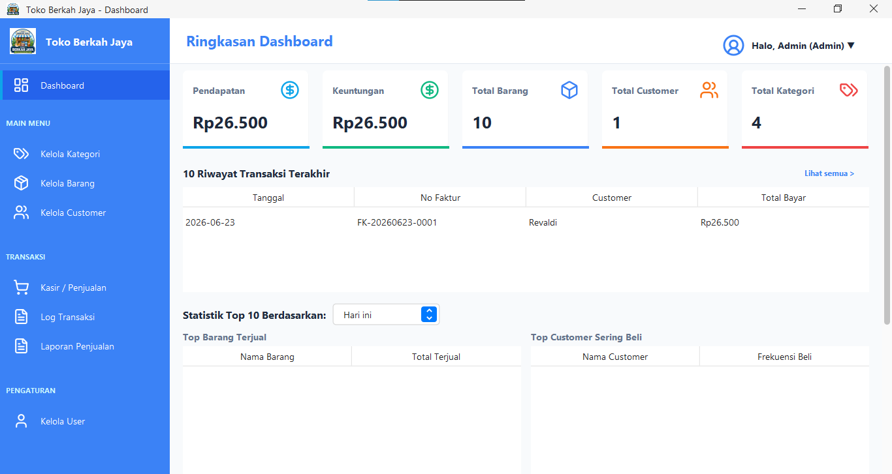

Nama Modul : Form BarangForm
Deskripsi : Form manajemen data master barang yang digunakan untuk menambah, membaca, memperbarui, dan menghapus data barang toko.
package ui;

import model.Barang;
import model.Kategori;
import service.BarangService;
import service.KategoriService;
import ui.components.Toast;
import util.Formatter;

import javax.swing.*;
import javax.swing.border.EmptyBorder;
import javax.swing.table.DefaultTableModel;
import util.ThemeUtil;
import util.ValidationUtil;
import ui.components.RoundedPanel;
import java.awt.*;
import java.awt.event.ActionListener;
import java.awt.event.MouseAdapter;
import java.awt.event.MouseEvent;
import java.util.List;

public class BarangForm extends JPanel {

private JTextField txtId, txtNama, txtHargaBeli, txtHargaJual, txtStok, txtSearch;
private JComboBox<String> cbKategori, comboSatuan, cbFilterKategori;
private JButton btnSimpan, btnHapus, btnClear;
private JTable table;
private DefaultTableModel tableModel;

private BarangService barangService;
private KategoriService kategoriService;
private List<Kategori> listKategori;

public BarangForm() {
barangService = new BarangService();
kategoriService = new KategoriService();

setLayout(new BorderLayout(20, 20));
setBackground(ThemeUtil.BG_SOFT);
setBorder(new EmptyBorder(20, 30, 20, 30));

initComponents();
loadComboKategori();
loadData();
clear();
}

private void initComponents() {

RoundedPanel panelTop = ThemeUtil.createCardPanel();
panelTop.setLayout(new BorderLayout(10, 10));

JPanel panelInput = new JPanel(new GridBagLayout());
panelInput.setOpaque(false);
GridBagConstraints gbc = new GridBagConstraints();
gbc.insets = new Insets(5, 5, 5, 15);
gbc.fill = GridBagConstraints.HORIZONTAL;
gbc.anchor = GridBagConstraints.WEST;

gbc.gridx = 0; gbc.gridy = 0; addLabel(panelInput, "ID Barang:", gbc);
txtId = new JTextField(20); ThemeUtil.styleTextField(txtId);
gbc.gridx = 1; panelInput.add(txtId, gbc);

gbc.gridx = 0; gbc.gridy = 1; addLabel(panelInput, "Nama Barang:", gbc);
txtNama = new JTextField(20); ThemeUtil.styleTextField(txtNama);
ValidationUtil.addRequiredValidation(txtNama);
gbc.gridx = 1; panelInput.add(txtNama, gbc);

gbc.gridx = 0; gbc.gridy = 2; addLabel(panelInput, "Kategori:", gbc);
cbKategori = new JComboBox<>(); ThemeUtil.styleComboBox(cbKategori);
util.AutoCompletion.enable(cbKategori);
gbc.gridx = 1; panelInput.add(cbKategori, gbc);

gbc.gridy = 3; gbc.gridx = 0; addLabel(panelInput, "Satuan:", gbc);
String[] daftarSatuan = {
"Pcs", "Pack", "Lusin", "Kodi", "Gross", "Dus", "Karton", "Box",
"Slop", "Rim", "Kg", "Gram", "Liter", "Mililiter", "Meter", "Centimeter",
"Botol", "Sachet", "Bungkus", "Ikat", "Roll", "Bal", "Karung",
"Lembar", "Set", "Pasang", "Tube", "Kaleng", "Galon"
};
comboSatuan = new JComboBox<>(daftarSatuan);
ThemeUtil.styleComboBox(comboSatuan);
gbc.gridx = 1; panelInput.add(comboSatuan, gbc);

gbc.gridx = 0; gbc.gridy = 4; addLabel(panelInput, "Harga Beli:", gbc);
txtHargaBeli = new JTextField(20); ThemeUtil.styleTextField(txtHargaBeli);
ThemeUtil.makeCurrencyField(txtHargaBeli);
ValidationUtil.addNumericValidation(txtHargaBeli);
gbc.gridx = 1; panelInput.add(txtHargaBeli, gbc);

gbc.gridx = 0; gbc.gridy = 5; addLabel(panelInput, "Harga Jual:", gbc);
txtHargaJual = new JTextField(20); ThemeUtil.styleTextField(txtHargaJual);
ThemeUtil.makeCurrencyField(txtHargaJual);
ValidationUtil.addNumericValidation(txtHargaJual);
gbc.gridx = 1; panelInput.add(txtHargaJual, gbc);

gbc.gridx = 0; gbc.gridy = 6; addLabel(panelInput, "Stok:", gbc);
txtStok = new JTextField(20); ThemeUtil.styleTextField(txtStok);
ThemeUtil.makeNumberOnly(txtStok);
ValidationUtil.addNumericValidation(txtStok);
gbc.gridx = 1; panelInput.add(txtStok, gbc);

JPanel panelBtn = new JPanel(new FlowLayout(FlowLayout.LEFT, 10, 0));
panelBtn.setOpaque(false);

btnSimpan = new JButton("Simpan"); ThemeUtil.styleButton(btnSimpan, ThemeUtil.SUCCESS_COLOR);
btnHapus = new JButton("Hapus"); ThemeUtil.styleButton(btnHapus, ThemeUtil.ERROR_COLOR);
btnClear = new JButton("Clear"); ThemeUtil.styleButton(btnClear, ThemeUtil.TEXT_SECONDARY);

panelBtn.add(btnSimpan);
panelBtn.add(btnHapus);
panelBtn.add(btnClear);

panelTop.add(panelInput, BorderLayout.WEST);
panelTop.add(panelBtn, BorderLayout.SOUTH);

add(panelTop, BorderLayout.NORTH);

RoundedPanel panelBottom = ThemeUtil.createCardPanel();
panelBottom.setLayout(new BorderLayout());

tableModel = new DefaultTableModel(new String[]{"ID Barang", "Nama Barang", "Kategori", "Satuan", "Harga Beli", "Harga Jual", "Stok"}, 0) {
public boolean isCellEditable(int row, int column) { return false; }
};
table = new JTable(tableModel);
JScrollPane scrollPane = new JScrollPane(table);
ThemeUtil.styleTable(table, scrollPane);

JPanel panelSearch = new JPanel(new FlowLayout(FlowLayout.RIGHT, 10, 5));
panelSearch.setOpaque(false);

JLabel lblFilter = new JLabel("Filter Kategori:");
lblFilter.setFont(ThemeUtil.FONT_REGULAR);
cbFilterKategori = new JComboBox<>();
util.AutoCompletion.enable(cbFilterKategori);
ThemeUtil.styleComboBox(cbFilterKategori);

JLabel lblSearch = new JLabel("Cari:");
lblSearch.setFont(ThemeUtil.FONT_REGULAR);
txtSearch = new JTextField(15);
ThemeUtil.styleTextField(txtSearch);

panelSearch.add(lblFilter);
panelSearch.add(cbFilterKategori);
panelSearch.add(lblSearch);
panelSearch.add(txtSearch);

panelBottom.add(panelSearch, BorderLayout.NORTH);
panelBottom.add(scrollPane, BorderLayout.CENTER);
add(panelBottom, BorderLayout.CENTER);

Runnable doSearch = () -> {
if (cbFilterKategori.getSelectedItem() != null) {
loadData(txtSearch.getText(), cbFilterKategori.getSelectedItem().toString());
}
};
cbFilterKategori.addActionListener(e -> doSearch.run());

txtSearch.getDocument().addDocumentListener(new javax.swing.event.DocumentListener() {
public void insertUpdate(javax.swing.event.DocumentEvent e) { doSearch.run(); }
public void removeUpdate(javax.swing.event.DocumentEvent e) { doSearch.run(); }
public void changedUpdate(javax.swing.event.DocumentEvent e) { doSearch.run(); }
});

btnSimpan.addActionListener(e -> simpanData());
btnHapus.addActionListener(e -> hapusData());
btnClear.addActionListener(e -> clear());

ActionListener enterSubmit = e -> {
btnSimpan.doClick();
};
txtNama.addActionListener(enterSubmit);
txtHargaBeli.addActionListener(enterSubmit);
txtHargaJual.addActionListener(enterSubmit);
txtStok.addActionListener(enterSubmit);

table.addMouseListener(new MouseAdapter() {
public void mouseClicked(MouseEvent e) {
int row = table.getSelectedRow();
if (row >= 0) {
txtId.setText(tableModel.getValueAt(row, 0).toString());
txtId.setEditable(false);
txtNama.setText(tableModel.getValueAt(row, 1).toString());
cbKategori.setSelectedItem(tableModel.getValueAt(row, 2).toString());
comboSatuan.setSelectedItem(tableModel.getValueAt(row, 3).toString());
txtHargaBeli.setText(tableModel.getValueAt(row, 4).toString().replace(".0", ""));
txtHargaJual.setText(tableModel.getValueAt(row, 5).toString().replace(".0", ""));
txtStok.setText(tableModel.getValueAt(row, 6).toString());
}
}
});
}

private void addLabel(JPanel p, String text, GridBagConstraints gbc) {
JLabel lbl = new JLabel(text);
lbl.setFont(ThemeUtil.FONT_REGULAR);
lbl.setForeground(ThemeUtil.TEXT_SECONDARY);
p.add(lbl, gbc);
}

public void loadComboKategori() {

listKategori = kategoriService.getAllKategori();

cbKategori.removeAllItems();
cbFilterKategori.removeAllItems();
cbFilterKategori.addItem("Semua Kategori");

for (Kategori k : listKategori) {
cbKategori.addItem(k.getNamaKategori());
cbFilterKategori.addItem(k.getNamaKategori());
}
}

public void loadData() {
loadData("", "Semua Kategori");
}

public void loadData(String keyword, String filterKategori) {
tableModel.setRowCount(0);

List<Barang> list = barangService.searchBarang(keyword, filterKategori);

for (Barang b : list) {
String namaKat = "";

for(Kategori k : listKategori) {
if(k.getIdKategori() == b.getIdKategori()) {
namaKat = k.getNamaKategori();
break;
}
}

tableModel.addRow(new Object[]{
b.getIdBarang(), b.getNamaBarang(), namaKat,
b.getSatuan(), Formatter.formatRupiah(b.getHargaBeli()), Formatter.formatRupiah(b.getHargaJual()), b.getStok()
});
}
}

private void clear() {
txtId.setText(barangService.generateId());
txtId.setEditable(false);
txtNama.setText("");
comboSatuan.setSelectedIndex(0);
txtHargaBeli.setText("");
txtHargaJual.setText("");
txtStok.setText("");
if(cbKategori.getItemCount() > 0) cbKategori.setSelectedIndex(0);
table.clearSelection();
}

private void simpanData() {
if (txtNama.getText().trim().isEmpty()) {
Toast.showError((JFrame) SwingUtilities.getWindowAncestor(this), "Nama Barang tidak boleh kosong!");
return;
}

boolean isUpdate = table.getSelectedRow() >= 0;

try {

Barang b = new Barang();
b.setIdBarang(txtId.getText());
b.setNamaBarang(txtNama.getText().trim());
b.setIdKategori(listKategori.get(cbKategori.getSelectedIndex()).getIdKategori());
b.setSatuan(comboSatuan.getSelectedItem().toString());
b.setHargaBeli(Formatter.parseCurrencySafe(txtHargaBeli.getText()));
b.setHargaJual(Formatter.parseCurrencySafe(txtHargaJual.getText()));
b.setStok(Integer.parseInt(txtStok.getText().trim()));

if (isUpdate) {
if (barangService.updateBarang(b)) {
Toast.showSuccess((JFrame) SwingUtilities.getWindowAncestor(this), "Data berhasil diupdate");
loadData();
clear();
} else {
Toast.showError((JFrame) SwingUtilities.getWindowAncestor(this), "Gagal mengupdate data!");
}
} else {
if (barangService.tambahBarang(b)) {
Toast.showSuccess((JFrame) SwingUtilities.getWindowAncestor(this), "Data berhasil disimpan");
loadData();
clear();
} else {
Toast.showError((JFrame) SwingUtilities.getWindowAncestor(this), "Gagal menyimpan data!");
}
}
} catch (NumberFormatException ex) {
Toast.showError((JFrame) SwingUtilities.getWindowAncestor(this), "Harga/Stok harus angka!");
}
}

private void hapusData() {
if (table.getSelectedRow() < 0) {
Toast.showError((JFrame) SwingUtilities.getWindowAncestor(this), "Pilih data yang akan dihapus!");
return;
}

if (barangService.hapusBarang(txtId.getText())) {
Toast.showSuccess((JFrame) SwingUtilities.getWindowAncestor(this), "Data berhasil dihapus");
loadData();
clear();
} else {
Toast.showError((JFrame) SwingUtilities.getWindowAncestor(this), "Gagal menghapus data!");
}
}
}
Hasil:

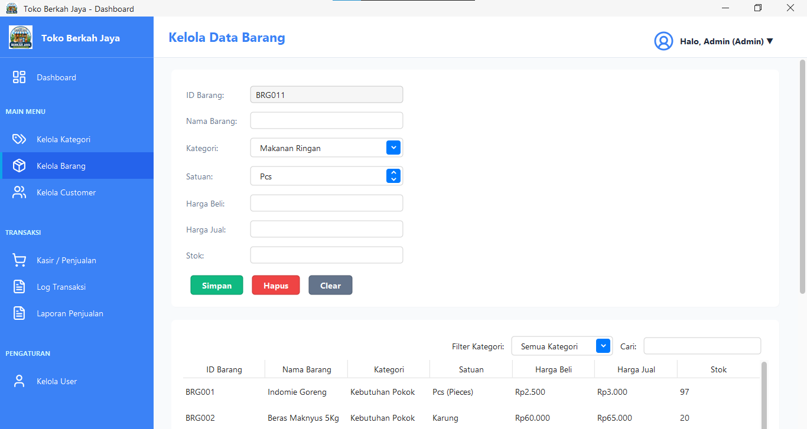

Nama Modul : Form KategoriForm
Deskripsi : Form manajemen data master kategori barang yang digunakan untuk mengelompokkan barang berdasarkan jenis kategori.
package ui;

import model.Kategori;
import service.KategoriService;
import ui.components.Toast;

import javax.swing.*;
import javax.swing.border.EmptyBorder;
import javax.swing.table.DefaultTableModel;
import util.ThemeUtil;
import util.ValidationUtil;
import ui.components.RoundedPanel;
import java.awt.*;
import java.awt.event.MouseAdapter;
import java.awt.event.MouseEvent;
import java.util.List;

public class KategoriForm extends JPanel {

private JTextField txtId, txtNama;
private JButton btnSimpan, btnHapus, btnClear;
private JTable table;
private DefaultTableModel tableModel;
private KategoriService service;

public KategoriForm() {
service = new KategoriService();
setLayout(new BorderLayout(20, 20));
setBackground(ThemeUtil.BG_SOFT);
setBorder(new EmptyBorder(20, 30, 20, 30));
initComponents();
loadData();
clear();
}

private void initComponents() {

RoundedPanel panelTop = ThemeUtil.createCardPanel();
panelTop.setLayout(new BorderLayout(10, 10));

JPanel panelInput = new JPanel(new GridBagLayout());
panelInput.setOpaque(false);
GridBagConstraints gbc = new GridBagConstraints();
gbc.insets = new Insets(5, 5, 5, 15);
gbc.fill = GridBagConstraints.HORIZONTAL;
gbc.anchor = GridBagConstraints.WEST;

gbc.gridx = 0; gbc.gridy = 0;
JLabel lblId = new JLabel("ID Kategori:");
lblId.setFont(ThemeUtil.FONT_REGULAR);
lblId.setForeground(ThemeUtil.TEXT_SECONDARY);
panelInput.add(lblId, gbc);

txtId = new JTextField(20);
ThemeUtil.styleTextField(txtId);
txtId.setEditable(false);
gbc.gridx = 1;
panelInput.add(txtId, gbc);

gbc.gridx = 0; gbc.gridy = 1;
JLabel lblNama = new JLabel("Nama Kategori:");
lblNama.setFont(ThemeUtil.FONT_REGULAR);
lblNama.setForeground(ThemeUtil.TEXT_SECONDARY);
panelInput.add(lblNama, gbc);

txtNama = new JTextField(20);
ThemeUtil.styleTextField(txtNama);
ValidationUtil.addRequiredValidation(txtNama);
gbc.gridx = 1;
panelInput.add(txtNama, gbc);

JPanel panelBtn = new JPanel(new FlowLayout(FlowLayout.LEFT, 10, 0));
panelBtn.setOpaque(false);

btnSimpan = new JButton("Simpan"); ThemeUtil.styleButton(btnSimpan, ThemeUtil.SUCCESS_COLOR);
btnHapus = new JButton("Hapus"); ThemeUtil.styleButton(btnHapus, ThemeUtil.ERROR_COLOR);
btnClear = new JButton("Clear"); ThemeUtil.styleButton(btnClear, ThemeUtil.TEXT_SECONDARY);

panelBtn.add(btnSimpan);
panelBtn.add(btnHapus);
panelBtn.add(btnClear);

panelTop.add(panelInput, BorderLayout.WEST);
panelTop.add(panelBtn, BorderLayout.SOUTH);

add(panelTop, BorderLayout.NORTH);

RoundedPanel panelBottom = ThemeUtil.createCardPanel();
panelBottom.setLayout(new BorderLayout());

tableModel = new DefaultTableModel(new String[]{"ID Kategori", "Nama Kategori"}, 0) {
@Override
public boolean isCellEditable(int row, int column) { return false; }
};
table = new JTable(tableModel);
JScrollPane scrollPane = new JScrollPane(table);

ThemeUtil.styleTable(table, scrollPane);

JPanel panelSearch = new JPanel(new FlowLayout(FlowLayout.RIGHT, 10, 5));
panelSearch.setOpaque(false);
JLabel lblSearch = new JLabel("Cari:");
lblSearch.setFont(ThemeUtil.FONT_REGULAR);
JTextField txtSearch = new JTextField(15);
ThemeUtil.styleTextField(txtSearch);
panelSearch.add(lblSearch);
panelSearch.add(txtSearch);

panelBottom.add(panelSearch, BorderLayout.NORTH);
panelBottom.add(scrollPane, BorderLayout.CENTER);
add(panelBottom, BorderLayout.CENTER);

txtSearch.getDocument().addDocumentListener(new javax.swing.event.DocumentListener() {
public void insertUpdate(javax.swing.event.DocumentEvent e) { loadData(txtSearch.getText()); }
public void removeUpdate(javax.swing.event.DocumentEvent e) { loadData(txtSearch.getText()); }
public void changedUpdate(javax.swing.event.DocumentEvent e) { loadData(txtSearch.getText()); }
});

btnSimpan.addActionListener(e -> simpanData());
btnHapus.addActionListener(e -> hapusData());
btnClear.addActionListener(e -> clear());

txtNama.addActionListener(e -> {
btnSimpan.doClick();
});

table.addMouseListener(new MouseAdapter() {
@Override
public void mouseClicked(MouseEvent e) {
int row = table.getSelectedRow();
if (row >= 0) {
txtId.setText(tableModel.getValueAt(row, 0).toString());
txtNama.setText(tableModel.getValueAt(row, 1).toString());
}
}
});
}

public void loadData() {
loadData("");
}

private void loadData(String keyword) {
tableModel.setRowCount(0);
List<Kategori> list = keyword.isEmpty() ? service.getAllKategori() : service.searchKategori(keyword);
for (Kategori k : list) {
tableModel.addRow(new Object[]{k.getIdKategori(), k.getNamaKategori()});
}
}

private void clear() {
txtId.setText(service.getNextAutoIncrement());
txtNama.setText("");
table.clearSelection();
}

private void simpanData() {
if (txtNama.getText().trim().isEmpty()) {
Toast.showError((JFrame) SwingUtilities.getWindowAncestor(this), "Nama kategori tidak boleh kosong!");
return;
}

boolean isUpdate = table.getSelectedRow() >= 0;

Kategori k = new Kategori();
try {
k.setIdKategori(Integer.parseInt(txtId.getText()));
} catch (Exception e) {}
k.setNamaKategori(txtNama.getText().trim());

if (isUpdate) {
if (service.updateKategori(k)) {
Toast.showSuccess((JFrame) SwingUtilities.getWindowAncestor(this), "Data berhasil diupdate");
loadData();
clear();
} else {
Toast.showError((JFrame) SwingUtilities.getWindowAncestor(this), "Gagal mengupdate data!");
}
} else {
if (service.tambahKategori(k)) {
Toast.showSuccess((JFrame) SwingUtilities.getWindowAncestor(this), "Data berhasil disimpan");
loadData();
clear();
} else {
Toast.showError((JFrame) SwingUtilities.getWindowAncestor(this), "Gagal menyimpan data!");
}
}
}

private void hapusData() {
if (table.getSelectedRow() < 0) {
Toast.showError((JFrame) SwingUtilities.getWindowAncestor(this), "Pilih data yang akan dihapus!");
return;
}

int idKat = 0;
try {
idKat = Integer.parseInt(txtId.getText());
} catch (Exception e) {}

if (service.hapusKategori(idKat)) {
Toast.showSuccess((JFrame) SwingUtilities.getWindowAncestor(this), "Data berhasil dihapus");
loadData();
clear();
} else {
Toast.showError((JFrame) SwingUtilities.getWindowAncestor(this), "Gagal menghapus data!");
}
}
}
Hasil:

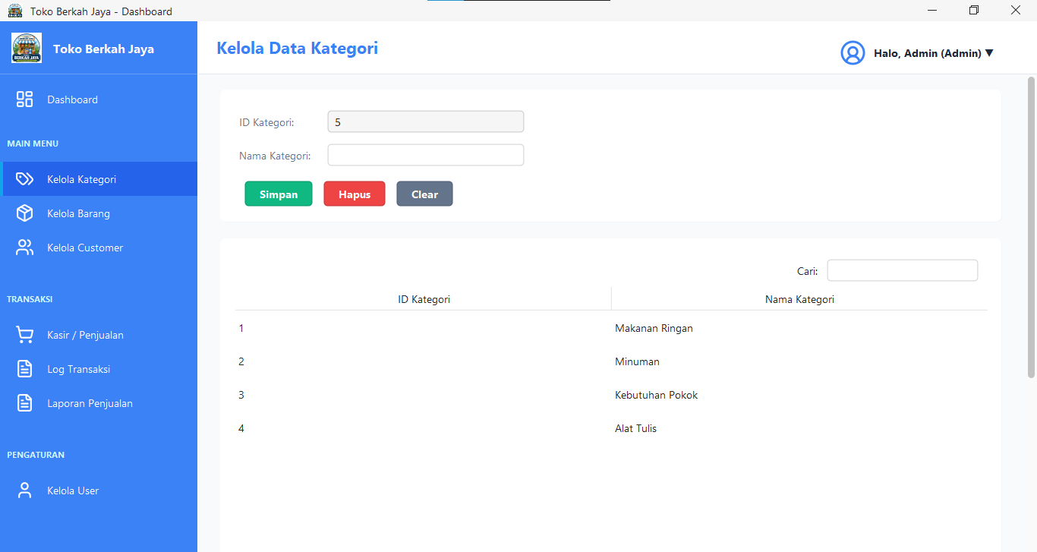

Nama Modul : Form CustomerForm
Deskripsi : Form manajemen data master customer (pelanggan) yang digunakan untuk melakukan operasi CRUD data pelanggan.
package ui;

import model.Customer;
import service.CustomerService;
import ui.components.Toast;

import javax.swing.*;
import javax.swing.border.EmptyBorder;
import javax.swing.table.DefaultTableModel;
import util.ThemeUtil;
import util.ValidationUtil;
import ui.components.RoundedPanel;
import java.awt.*;
import java.awt.event.ActionListener;
import java.awt.event.MouseAdapter;
import java.awt.event.MouseEvent;
import java.util.List;

public class CustomerForm extends JPanel {

private JTextField txtId, txtNama, txtTelepon;
private JTextArea txtAlamat;
private JButton btnSimpan, btnHapus, btnClear;
private JTable table;
private DefaultTableModel tableModel;
private CustomerService service;

public CustomerForm() {
service = new CustomerService();
setLayout(new BorderLayout(20, 20));
setBackground(ThemeUtil.BG_SOFT);
setBorder(new EmptyBorder(20, 30, 20, 30));
initComponents();
loadData();
clear();
}

private void initComponents() {

RoundedPanel panelTop = ThemeUtil.createCardPanel();
panelTop.setLayout(new BorderLayout(10, 10));

JPanel panelInput = new JPanel(new GridBagLayout());
panelInput.setOpaque(false);
GridBagConstraints gbc = new GridBagConstraints();
gbc.insets = new Insets(5, 5, 5, 15);
gbc.fill = GridBagConstraints.HORIZONTAL;
gbc.anchor = GridBagConstraints.WEST;

gbc.gridx = 0; gbc.gridy = 0; addLabel(panelInput, "ID Customer:", gbc);
txtId = new JTextField(20); ThemeUtil.styleTextField(txtId); txtId.setEditable(false);
gbc.gridx = 1; panelInput.add(txtId, gbc);

gbc.gridx = 0; gbc.gridy = 1; addLabel(panelInput, "Nama Customer:", gbc);
txtNama = new JTextField(20); ThemeUtil.styleTextField(txtNama);
ValidationUtil.addAlphabetValidation(txtNama);
gbc.gridx = 1; panelInput.add(txtNama, gbc);

gbc.gridx = 0; gbc.gridy = 2; addLabel(panelInput, "Alamat:", gbc);
txtAlamat = new JTextArea(3, 20); ThemeUtil.styleTextArea(txtAlamat);
gbc.gridx = 1; panelInput.add(new JScrollPane(txtAlamat), gbc);

gbc.gridx = 0; gbc.gridy = 3; addLabel(panelInput, "No Telepon:", gbc);
txtTelepon = new JTextField(20); ThemeUtil.styleTextField(txtTelepon);
ThemeUtil.makeNumberOnly(txtTelepon);
ValidationUtil.addNumericValidation(txtTelepon);
gbc.gridx = 1; panelInput.add(txtTelepon, gbc);

JPanel panelBtn = new JPanel(new FlowLayout(FlowLayout.LEFT, 10, 0));
panelBtn.setOpaque(false);
btnSimpan = new JButton("Simpan"); ThemeUtil.styleButton(btnSimpan, ThemeUtil.SUCCESS_COLOR);
btnHapus = new JButton("Hapus"); ThemeUtil.styleButton(btnHapus, ThemeUtil.ERROR_COLOR);
btnClear = new JButton("Clear"); ThemeUtil.styleButton(btnClear, ThemeUtil.TEXT_SECONDARY);

panelBtn.add(btnSimpan);
panelBtn.add(btnHapus);
panelBtn.add(btnClear);

panelTop.add(panelInput, BorderLayout.WEST);
panelTop.add(panelBtn, BorderLayout.SOUTH);

add(panelTop, BorderLayout.NORTH);

RoundedPanel panelBottom = ThemeUtil.createCardPanel();
panelBottom.setLayout(new BorderLayout());

tableModel = new DefaultTableModel(new String[]{"ID Customer", "Nama Customer", "Alamat", "No Telepon"}, 0) {
public boolean isCellEditable(int row, int column) { return false; }
};
table = new JTable(tableModel);
JScrollPane scrollPane = new JScrollPane(table);
ThemeUtil.styleTable(table, scrollPane);

JPanel panelSearch = new JPanel(new FlowLayout(FlowLayout.RIGHT, 10, 5));
panelSearch.setOpaque(false);
JLabel lblSearch = new JLabel("Cari:");
lblSearch.setFont(ThemeUtil.FONT_REGULAR);
JTextField txtSearch = new JTextField(15);
ThemeUtil.styleTextField(txtSearch);
panelSearch.add(lblSearch);
panelSearch.add(txtSearch);

panelBottom.add(panelSearch, BorderLayout.NORTH);
panelBottom.add(scrollPane, BorderLayout.CENTER);
add(panelBottom, BorderLayout.CENTER);

txtSearch.getDocument().addDocumentListener(new javax.swing.event.DocumentListener() {
public void insertUpdate(javax.swing.event.DocumentEvent e) { loadData(txtSearch.getText()); }
public void removeUpdate(javax.swing.event.DocumentEvent e) { loadData(txtSearch.getText()); }
public void changedUpdate(javax.swing.event.DocumentEvent e) { loadData(txtSearch.getText()); }
});

btnSimpan.addActionListener(e -> simpanData());
btnHapus.addActionListener(e -> hapusData());
btnClear.addActionListener(e -> clear());

table.addMouseListener(new MouseAdapter() {
public void mouseClicked(MouseEvent e) {
int row = table.getSelectedRow();
if (row >= 0) {
txtId.setText(tableModel.getValueAt(row, 0).toString());
txtId.setEditable(false);
txtNama.setText(tableModel.getValueAt(row, 1).toString());
txtAlamat.setText(tableModel.getValueAt(row, 2).toString());
txtTelepon.setText(tableModel.getValueAt(row, 3).toString());
}
}
});
}

private void addLabel(JPanel p, String text, GridBagConstraints gbc) {
JLabel lbl = new JLabel(text);
lbl.setFont(ThemeUtil.FONT_REGULAR);
lbl.setForeground(ThemeUtil.TEXT_SECONDARY);
p.add(lbl, gbc);
}

public void loadData() {
loadData("");
}

private void loadData(String keyword) {
tableModel.setRowCount(0);
List<Customer> list = keyword.isEmpty() ? service.getAllCustomer() : service.searchCustomer(keyword);
for (Customer c : list) {
tableModel.addRow(new Object[]{c.getIdCustomer(), c.getNamaCustomer(), c.getAlamat(), c.getTelepon()});
}
}

private void clear() {
txtId.setText(service.generateId());
txtId.setEditable(false);
txtNama.setText("");
txtAlamat.setText("");
txtTelepon.setText("");
table.clearSelection();
}

private void simpanData() {
if (txtNama.getText().trim().isEmpty() || txtAlamat.getText().trim().isEmpty() || txtTelepon.getText().trim().isEmpty()) {
Toast.showError((JFrame) SwingUtilities.getWindowAncestor(this), "Semua field harus diisi!");
return;
}

boolean isUpdate = table.getSelectedRow() >= 0;

Customer c = new Customer();
c.setIdCustomer(txtId.getText());
c.setNamaCustomer(txtNama.getText().trim());
c.setAlamat(txtAlamat.getText().trim());
c.setTelepon(txtTelepon.getText().trim());

if (isUpdate) {
if (service.updateCustomer(c)) {
Toast.showSuccess((JFrame) SwingUtilities.getWindowAncestor(this), "Data berhasil diupdate");
loadData();
clear();
} else {
Toast.showError((JFrame) SwingUtilities.getWindowAncestor(this), "Gagal mengupdate data!");
}
} else {
if (service.tambahCustomer(c)) {
Toast.showSuccess((JFrame) SwingUtilities.getWindowAncestor(this), "Data berhasil disimpan");
loadData();
clear();
} else {
Toast.showError((JFrame) SwingUtilities.getWindowAncestor(this), "Gagal menyimpan data!");
}
}
}

private void hapusData() {
if (table.getSelectedRow() < 0) {
Toast.showError((JFrame) SwingUtilities.getWindowAncestor(this), "Pilih data yang akan dihapus!");
return;
}

if (service.hapusCustomer(txtId.getText())) {
Toast.showSuccess((JFrame) SwingUtilities.getWindowAncestor(this), "Data berhasil dihapus");
loadData();
clear();
} else {
Toast.showError((JFrame) SwingUtilities.getWindowAncestor(this), "Gagal menghapus data!");
}
}
}
Hasil:

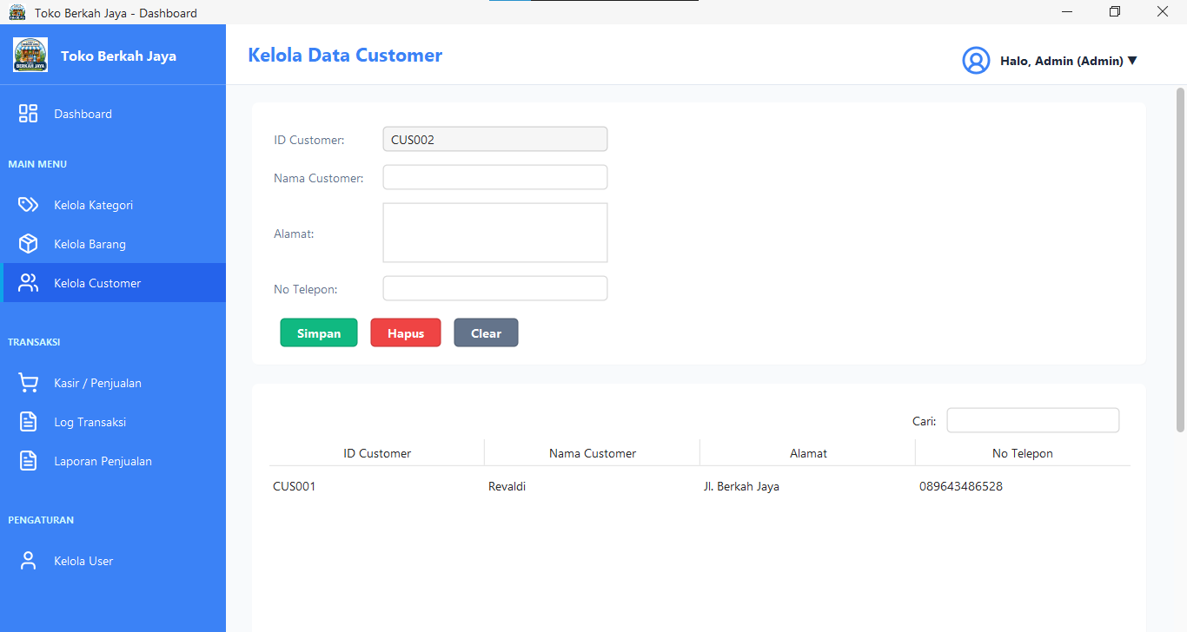

Nama Modul : Form UserForm
Deskripsi : Form manajemen data pengguna aplikasi (Admin & Kasir) yang digunakan untuk mengelola data akun pengguna.
package ui;

import model.User;
import service.UserService;
import ui.components.Toast;

import javax.swing.*;
import javax.swing.border.EmptyBorder;
import javax.swing.table.DefaultTableModel;
import util.ThemeUtil;
import util.ValidationUtil;
import ui.components.RoundedPanel;
import java.awt.*;
import java.awt.event.ActionListener;
import java.awt.event.MouseAdapter;
import java.awt.event.MouseEvent;
import java.util.List;

public class UserForm extends JPanel {

private JTextField txtId, txtUsername, txtNamaLengkap;
private JPasswordField txtPassword;
private JComboBox<String> cbRole;
private JButton btnSimpan, btnHapus, btnClear;
private JTable table;
private DefaultTableModel tableModel;
private UserService service;

public UserForm() {
service = new UserService();
setLayout(new BorderLayout(20, 20));
setBackground(ThemeUtil.BG_SOFT);
setBorder(new EmptyBorder(20, 30, 20, 30));
initComponents();
loadData();
clear();
}

private void initComponents() {

RoundedPanel panelTop = ThemeUtil.createCardPanel();
panelTop.setLayout(new BorderLayout(10, 10));

JPanel panelInput = new JPanel(new GridBagLayout());
panelInput.setOpaque(false);
GridBagConstraints gbc = new GridBagConstraints();
gbc.insets = new Insets(5, 5, 5, 15);
gbc.fill = GridBagConstraints.HORIZONTAL;
gbc.anchor = GridBagConstraints.WEST;

gbc.gridx = 0; gbc.gridy = 0;
addLabel(panelInput, "ID User:", gbc);
txtId = new JTextField(20);
ThemeUtil.styleTextField(txtId);
txtId.setEditable(false);
gbc.gridx = 1; panelInput.add(txtId, gbc);

gbc.gridx = 0; gbc.gridy = 1;
addLabel(panelInput, "Username:", gbc);
txtUsername = new JTextField(20);
ThemeUtil.styleTextField(txtUsername);
ValidationUtil.addRequiredValidation(txtUsername);
gbc.gridx = 1; panelInput.add(txtUsername, gbc);

gbc.gridx = 0; gbc.gridy = 2;
addLabel(panelInput, "Password:", gbc);
txtPassword = new JPasswordField(20);
ThemeUtil.stylePasswordField(txtPassword);
ValidationUtil.addRequiredValidation(txtPassword);
gbc.gridx = 1; panelInput.add(txtPassword, gbc);

gbc.gridx = 0; gbc.gridy = 3;
addLabel(panelInput, "Nama Lengkap:", gbc);
txtNamaLengkap = new JTextField(20);
ThemeUtil.styleTextField(txtNamaLengkap);
ValidationUtil.addAlphabetValidation(txtNamaLengkap);
gbc.gridx = 1; panelInput.add(txtNamaLengkap, gbc);

gbc.gridx = 0; gbc.gridy = 4;
addLabel(panelInput, "Role/Level:", gbc);
cbRole = new JComboBox<>(new String[]{"Admin", "Kasir"});
ThemeUtil.styleComboBox(cbRole);
gbc.gridx = 1; panelInput.add(cbRole, gbc);

JPanel panelBtn = new JPanel(new FlowLayout(FlowLayout.LEFT, 10, 0));
panelBtn.setOpaque(false);
btnSimpan = new JButton("Simpan"); ThemeUtil.styleButton(btnSimpan, ThemeUtil.SUCCESS_COLOR);
btnHapus = new JButton("Hapus"); ThemeUtil.styleButton(btnHapus, ThemeUtil.ERROR_COLOR);
btnClear = new JButton("Clear"); ThemeUtil.styleButton(btnClear, ThemeUtil.TEXT_SECONDARY);

panelBtn.add(btnSimpan);
panelBtn.add(btnHapus);
panelBtn.add(btnClear);

panelTop.add(panelInput, BorderLayout.WEST);
panelTop.add(panelBtn, BorderLayout.SOUTH);

add(panelTop, BorderLayout.NORTH);

RoundedPanel panelBottom = ThemeUtil.createCardPanel();
panelBottom.setLayout(new BorderLayout());

tableModel = new DefaultTableModel(new String[]{"ID User", "Username", "Nama Lengkap", "Role"}, 0) {
public boolean isCellEditable(int row, int column) { return false; }
};
table = new JTable(tableModel);
JScrollPane scrollPane = new JScrollPane(table);
ThemeUtil.styleTable(table, scrollPane);

JPanel panelSearch = new JPanel(new FlowLayout(FlowLayout.RIGHT, 10, 5));
panelSearch.setOpaque(false);

JLabel lblFilter = new JLabel("Filter Role:");
lblFilter.setFont(ThemeUtil.FONT_REGULAR);
JComboBox<String> cbFilterRole = new JComboBox<>(new String[]{"Semua Role", "Admin", "Kasir"});
ThemeUtil.styleComboBox(cbFilterRole);

JLabel lblSearch = new JLabel("Cari:");
lblSearch.setFont(ThemeUtil.FONT_REGULAR);
JTextField txtSearch = new JTextField(15);
ThemeUtil.styleTextField(txtSearch);

panelSearch.add(lblFilter);
panelSearch.add(cbFilterRole);
panelSearch.add(lblSearch);
panelSearch.add(txtSearch);

panelBottom.add(panelSearch, BorderLayout.NORTH);
panelBottom.add(scrollPane, BorderLayout.CENTER);
add(panelBottom, BorderLayout.CENTER);

Runnable doSearch = () -> {
loadData(txtSearch.getText(), cbFilterRole.getSelectedItem().toString());
};

cbFilterRole.addActionListener(e -> doSearch.run());

txtSearch.getDocument().addDocumentListener(new javax.swing.event.DocumentListener() {
public void insertUpdate(javax.swing.event.DocumentEvent e) { doSearch.run(); }
public void removeUpdate(javax.swing.event.DocumentEvent e) { doSearch.run(); }
public void changedUpdate(javax.swing.event.DocumentEvent e) { doSearch.run(); }
});

btnSimpan.addActionListener(e -> simpanData());
btnHapus.addActionListener(e -> hapusData());
btnClear.addActionListener(e -> clear());

ActionListener enterSubmit = e -> {
btnSimpan.doClick();
};
txtUsername.addActionListener(enterSubmit);
txtPassword.addActionListener(enterSubmit);
txtNamaLengkap.addActionListener(enterSubmit);

table.addMouseListener(new MouseAdapter() {
public void mouseClicked(MouseEvent e) {
int row = table.getSelectedRow();
if (row >= 0) {
txtId.setText(tableModel.getValueAt(row, 0).toString());
txtUsername.setText(tableModel.getValueAt(row, 1).toString());
txtPassword.setText("");
txtNamaLengkap.setText(tableModel.getValueAt(row, 2).toString());
cbRole.setSelectedItem(tableModel.getValueAt(row, 3).toString());
}
}
});
}

private void addLabel(JPanel p, String text, GridBagConstraints gbc) {
JLabel lbl = new JLabel(text);
lbl.setFont(ThemeUtil.FONT_REGULAR);
lbl.setForeground(ThemeUtil.TEXT_SECONDARY);
p.add(lbl, gbc);
}

public void loadData() {
loadData("", "Semua Role");
}

private void loadData(String keyword, String filterRole) {
tableModel.setRowCount(0);
List<User> list = service.searchUser(keyword, filterRole);
for (User u : list) {
tableModel.addRow(new Object[]{u.getIdUser(), u.getUsername(), u.getNamaLengkap(), u.getLevel()});
}
}

public void clear() {
txtId.setText(service.getNextAutoIncrement());
txtUsername.setText("");
txtPassword.setText("");
txtNamaLengkap.setText("");
cbRole.setSelectedIndex(0);
table.clearSelection();
}

private void simpanData() {
boolean isUpdate = table.getSelectedRow() >= 0;

if (txtUsername.getText().trim().isEmpty() || (!isUpdate && new String(txtPassword.getPassword()).trim().isEmpty())) {
Toast.showError((JFrame) SwingUtilities.getWindowAncestor(this), "Username dan Password tidak boleh kosong");
return;
}

String passwordInput = new String(txtPassword.getPassword());

User u = new User();
if (isUpdate) {
try {
u.setIdUser(Integer.parseInt(txtId.getText()));
} catch (NumberFormatException e) {
Toast.showError((JFrame) SwingUtilities.getWindowAncestor(this), "ID User tidak valid");
return;
}
}

u.setUsername(txtUsername.getText().trim());
u.setNamaLengkap(txtNamaLengkap.getText().trim());
u.setLevel(cbRole.getSelectedItem().toString());

if (isUpdate) {
if (!passwordInput.isEmpty()) {
u.setPassword(passwordInput);
} else {

User old = null;
List<User> users = service.searchUser("", "Semua Role");
for(User userOld : users) {
if(userOld.getIdUser() == u.getIdUser()) {
old = userOld;
break;
}
}
if (old != null) {
u.setPassword(old.getPassword());
}
}

if (service.updateUser(u)) {
Toast.showSuccess((JFrame) SwingUtilities.getWindowAncestor(this), "User diupdate");
loadData();
clear();
} else {
Toast.showError((JFrame) SwingUtilities.getWindowAncestor(this), "Gagal mengupdate user");
}
} else {
u.setPassword(passwordInput);
if (service.tambahUser(u)) {
Toast.showSuccess((JFrame) SwingUtilities.getWindowAncestor(this), "User disimpan");
loadData();
clear();
} else {
Toast.showError((JFrame) SwingUtilities.getWindowAncestor(this), "Gagal menyimpan user");
}
}
}

private void hapusData() {
if (table.getSelectedRow() < 0) {
Toast.showError((JFrame) SwingUtilities.getWindowAncestor(this), "Pilih data!");
return;
}

int idUser;
try {
idUser = Integer.parseInt(txtId.getText());
} catch (NumberFormatException e) {
Toast.showError((JFrame) SwingUtilities.getWindowAncestor(this), "ID User tidak valid");
return;
}

if (service.hapusUser(idUser)) {
Toast.showSuccess((JFrame) SwingUtilities.getWindowAncestor(this), "User dihapus");
loadData();
clear();
} else {
Toast.showError((JFrame) SwingUtilities.getWindowAncestor(this), "Gagal menghapus user");
}
}
}
Hasil:

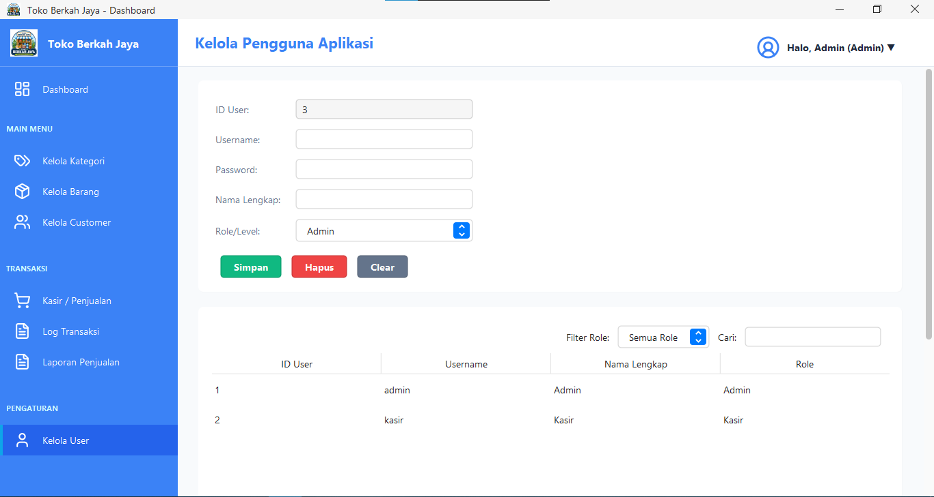

Nama Modul : Form PenjualanForm
Deskripsi : Form transaksi kasir yang digunakan untuk melayani proses transaksi penjualan, memasukkan barang ke keranjang belanja, menghitung kembalian uang, dan mencetak struk belanja.
package ui;

import model.Barang;
import model.Customer;
import model.Penjualan;
import model.DetailPenjualan;
import model.User;
import service.BarangService;
import service.CustomerService;
import service.PenjualanService;
import ui.components.Toast;

import javax.swing.*;
import javax.swing.border.EmptyBorder;
import javax.swing.table.DefaultTableModel;
import util.ThemeUtil;
import util.ValidationUtil;
import ui.components.RoundedPanel;
import java.awt.*;
import java.awt.event.ActionEvent;
import java.awt.event.ActionListener;
import java.util.ArrayList;
import java.util.Date;
import java.util.List;

public class PenjualanForm extends JPanel {

private JTextField txtIdTrans, txtTanggal, txtQty, txtTotal, txtBayar, txtKembali;
private JComboBox<String> cbCustomer, cbBarang;
private JButton btnTambah, btnSimpan, btnClear;
private JTable tableKeranjang;
private DefaultTableModel modelKeranjang;

private BarangService barangService;
private CustomerService customerService;
private PenjualanService penjualanService;

private List<Customer> listCustomer;
private List<Barang> listBarang;
private List<DetailPenjualan> keranjang;
private User currentUser;

private double grandTotal = 0;

public PenjualanForm(User user) {
this.currentUser = user;
barangService = new BarangService();
customerService = new CustomerService();
penjualanService = new PenjualanService();
keranjang = new ArrayList<>();

setLayout(new BorderLayout(20, 20));
setBackground(ThemeUtil.BG_SOFT);
setBorder(new EmptyBorder(20, 30, 20, 30));

initComponents();
loadCombo();
clearForm();
}

private void initComponents() {

RoundedPanel panelInput = ThemeUtil.createCardPanel();
panelInput.setLayout(new GridBagLayout());
GridBagConstraints gbc = new GridBagConstraints();
gbc.insets = new Insets(5, 5, 5, 15);
gbc.fill = GridBagConstraints.HORIZONTAL;
gbc.anchor = GridBagConstraints.WEST;

gbc.gridx = 0; gbc.gridy = 0;
addLabel(panelInput, "No Faktur:", gbc);
txtIdTrans = new JTextField(15);
ThemeUtil.styleTextField(txtIdTrans);
txtIdTrans.setEditable(false);
gbc.gridx = 1; panelInput.add(txtIdTrans, gbc);

gbc.gridx = 0; gbc.gridy = 1;
addLabel(panelInput, "Tanggal:", gbc);
txtTanggal = new JTextField(15);
ThemeUtil.styleTextField(txtTanggal);
txtTanggal.setEditable(false);
txtTanggal.setText(new java.text.SimpleDateFormat("yyyy-MM-dd").format(new Date()));
gbc.gridx = 1; panelInput.add(txtTanggal, gbc);

gbc.gridx = 0; gbc.gridy = 2;
addLabel(panelInput, "Customer:", gbc);
cbCustomer = new JComboBox<>();
util.AutoCompletion.enable(cbCustomer);
ThemeUtil.styleComboBox(cbCustomer);
gbc.gridx = 1; panelInput.add(cbCustomer, gbc);

gbc.gridx = 0; gbc.gridy = 3;
addLabel(panelInput, "Barang:", gbc);
cbBarang = new JComboBox<>();
util.AutoCompletion.enable(cbBarang);
ThemeUtil.styleComboBox(cbBarang);
gbc.gridx = 1; panelInput.add(cbBarang, gbc);

gbc.gridx = 0; gbc.gridy = 4;
addLabel(panelInput, "Qty:", gbc);
txtQty = new JTextField(15);
ThemeUtil.styleTextField(txtQty);
ThemeUtil.makeNumberOnly(txtQty);
ValidationUtil.addNumericValidation(txtQty);
gbc.gridx = 1; panelInput.add(txtQty, gbc);

btnTambah = new JButton("Tambah ke Keranjang");
ThemeUtil.styleButton(btnTambah, ThemeUtil.OCEAN_BLUE);
gbc.gridx = 1; gbc.gridy = 5;
gbc.insets = new Insets(15, 5, 5, 15);
panelInput.add(btnTambah, gbc);

RoundedPanel panelTabel = ThemeUtil.createCardPanel();
panelTabel.setLayout(new BorderLayout());
modelKeranjang = new DefaultTableModel(new String[]{"ID Barang", "Nama Barang", "Harga", "Qty", "Subtotal"}, 0) {
public boolean isCellEditable(int row, int column) { return false; }
};
tableKeranjang = new JTable(modelKeranjang);
JScrollPane scrollTabel = new JScrollPane(tableKeranjang);
ThemeUtil.styleTable(tableKeranjang, scrollTabel);
panelTabel.add(scrollTabel, BorderLayout.CENTER);

RoundedPanel panelBayar = ThemeUtil.createCardPanel();
panelBayar.setLayout(new GridBagLayout());
GridBagConstraints gbcB = new GridBagConstraints();
gbcB.insets = new Insets(5, 5, 5, 15);
gbcB.fill = GridBagConstraints.HORIZONTAL;

gbcB.gridx = 0; gbcB.gridy = 0;
addLabel(panelBayar, "Total:", gbcB);
txtTotal = new JTextField(15);
ThemeUtil.styleTextField(txtTotal);
txtTotal.setEditable(false);
txtTotal.setFont(new Font("Segoe UI", Font.BOLD, 16));
gbcB.gridx = 1; panelBayar.add(txtTotal, gbcB);

gbcB.gridx = 0; gbcB.gridy = 1;
addLabel(panelBayar, "Bayar:", gbcB);
txtBayar = new JTextField(15);
ThemeUtil.styleTextField(txtBayar);
ThemeUtil.makeCurrencyField(txtBayar);
ValidationUtil.addNumericValidation(txtBayar);
txtBayar.setFont(new Font("Segoe UI", Font.BOLD, 16));
gbcB.gridx = 1; panelBayar.add(txtBayar, gbcB);

gbcB.gridx = 0; gbcB.gridy = 2;
addLabel(panelBayar, "Kembali:", gbcB);
txtKembali = new JTextField(15);
ThemeUtil.styleTextField(txtKembali);
txtKembali.setEditable(false);
txtKembali.setFont(new Font("Segoe UI", Font.BOLD, 16));
gbcB.gridx = 1; panelBayar.add(txtKembali, gbcB);

JPanel panelBtnSave = new JPanel(new FlowLayout(FlowLayout.RIGHT, 10, 0));
panelBtnSave.setOpaque(false);
btnSimpan = new JButton("Simpan Transaksi");
ThemeUtil.styleButton(btnSimpan, ThemeUtil.SUCCESS_COLOR);
btnClear = new JButton("Clear Keranjang");
ThemeUtil.styleButton(btnClear, ThemeUtil.ERROR_COLOR);
panelBtnSave.add(btnClear);
panelBtnSave.add(btnSimpan);

gbcB.gridx = 0; gbcB.gridy = 3;
gbcB.gridwidth = 2;
gbcB.insets = new Insets(20, 5, 5, 15);
panelBayar.add(panelBtnSave, gbcB);

JPanel panelUtama = new JPanel(new BorderLayout(15, 15));
panelUtama.setOpaque(false);

JPanel panelAtas = new JPanel(new BorderLayout(15, 15));
panelAtas.setOpaque(false);
panelAtas.add(panelInput, BorderLayout.WEST);
panelAtas.add(panelBayar, BorderLayout.CENTER);

panelUtama.add(panelAtas, BorderLayout.NORTH);
panelUtama.add(panelTabel, BorderLayout.CENTER);

add(panelUtama, BorderLayout.CENTER);

btnTambah.addActionListener(e -> tambahKeKeranjang());
btnClear.addActionListener(e -> clearForm());

txtQty.addActionListener(e -> btnTambah.doClick());

txtBayar.addActionListener(e -> {
hitungKembali();
btnSimpan.doClick();
});
btnSimpan.addActionListener(e -> simpanTransaksi());

txtBayar.getDocument().addDocumentListener(new javax.swing.event.DocumentListener() {
public void insertUpdate(javax.swing.event.DocumentEvent e) { hitungKembali(); }
public void removeUpdate(javax.swing.event.DocumentEvent e) { hitungKembali(); }
public void changedUpdate(javax.swing.event.DocumentEvent e) { hitungKembali(); }
});
}

private void addLabel(JPanel p, String text, GridBagConstraints gbc) {
JLabel lbl = new JLabel(text);
lbl.setFont(ThemeUtil.FONT_REGULAR);
lbl.setForeground(ThemeUtil.TEXT_SECONDARY);
p.add(lbl, gbc);
}

public void loadCombo() {
cbCustomer.removeAllItems();
listCustomer = customerService.getAllCustomer();
for (Customer c : listCustomer) {
cbCustomer.addItem(c.getNamaCustomer() + " (" + c.getIdCustomer() + ")");
}

cbBarang.removeAllItems();
listBarang = barangService.getAllBarang();
for (Barang b : listBarang) {
cbBarang.addItem(b.getNamaBarang() + " - " + util.Formatter.formatRupiah(b.getHargaJual()) + " (Stok: " + b.getStok() + ")");
}
}

public void loadData() {
refreshTabel();
}

public void clearForm() {
txtIdTrans.setText(penjualanService.getPreviewNoFaktur());
txtQty.setText("");
txtTotal.setText("0");
txtBayar.setText("");
txtKembali.setText("0");
keranjang.clear();
refreshTabel();
}

private void refreshTabel() {
modelKeranjang.setRowCount(0);
grandTotal = 0;
for (DetailPenjualan detail : keranjang) {
modelKeranjang.addRow(new Object[]{
detail.getIdBarang(),
getNamaBarang(detail.getIdBarang()),
util.Formatter.formatRupiah(detail.getHargaSatuan()),
detail.getJumlahBeli(),
util.Formatter.formatRupiah(detail.getSubtotal())
});
grandTotal += detail.getSubtotal();
}
txtTotal.setText(util.Formatter.formatRupiah(grandTotal));
txtBayar.setText("");
txtKembali.setText("");
}

private String getNamaBarang(String id) {
for (Barang b : listBarang) {
if (b.getIdBarang().equals(id)) return b.getNamaBarang();
}
return "-";
}

private void tambahKeKeranjang() {
if (cbBarang.getSelectedIndex() < 0) return;
try {
int qty = Integer.parseInt(txtQty.getText().trim());
if (qty <= 0) {
Toast.showError((JFrame) SwingUtilities.getWindowAncestor(this), "Qty harus lebih besar dari 0");
return;
}

Barang b = listBarang.get(cbBarang.getSelectedIndex());
if (b.getStok() < qty) {
Toast.showError((JFrame) SwingUtilities.getWindowAncestor(this), "Stok tidak mencukupi!");
return;
}

int totalDiminta = qty;
DetailPenjualan existingDetail = null;
for (DetailPenjualan pd : keranjang) {
if (pd.getIdBarang().equals(b.getIdBarang())) {
totalDiminta += pd.getJumlahBeli();
existingDetail = pd;
break;
}
}

if (b.getStok() < totalDiminta) {
Toast.showError((JFrame) SwingUtilities.getWindowAncestor(this), "Total permintaan (" + totalDiminta + ") melebihi sisa stok (" + b.getStok() + ")!");
return;
}

if (existingDetail != null) {

existingDetail.setJumlahBeli(totalDiminta);
existingDetail.setSubtotal(existingDetail.getJumlahBeli() * existingDetail.getHargaSatuan());
} else {

DetailPenjualan pd = new DetailPenjualan();
pd.setIdBarang(b.getIdBarang());
pd.setHargaSatuan(b.getHargaJual());
pd.setJumlahBeli(qty);
pd.setSubtotal(b.getHargaJual() * qty);
keranjang.add(pd);
}

txtQty.setText("");
refreshTabel();

} catch (NumberFormatException e) {
Toast.showError((JFrame) SwingUtilities.getWindowAncestor(this), "Qty harus angka!");
}
}

private void hitungKembali() {
try {
double bayar = util.Formatter.parseCurrencySafe(txtBayar.getText());
double kembali = bayar - grandTotal;
txtKembali.setText(util.Formatter.formatRupiah(kembali));
} catch (Exception e) {
txtKembali.setText("Error");
}
}

private void simpanTransaksi() {
if (keranjang.isEmpty()) {
Toast.showError((JFrame) SwingUtilities.getWindowAncestor(this), "Keranjang masih kosong!");
return;
}
if (cbCustomer.getSelectedIndex() < 0) {
Toast.showError((JFrame) SwingUtilities.getWindowAncestor(this), "Pilih customer!");
return;
}

try {
double bayar = util.Formatter.parseCurrencySafe(txtBayar.getText());
if (bayar < grandTotal) {
Toast.showError((JFrame) SwingUtilities.getWindowAncestor(this), "Uang bayar kurang!");
return;
}

Customer c = listCustomer.get(cbCustomer.getSelectedIndex());

Penjualan p = new Penjualan();
p.setNoFaktur(txtIdTrans.getText());
p.setTglTransaksi(new java.sql.Date(new Date().getTime()));
p.setIdCustomer(c.getIdCustomer());
p.setIdUser(currentUser != null ? currentUser.getIdUser() : 1);
p.setTotalBayar(grandTotal);

p.setDetails(keranjang);

if (penjualanService.simpanTransaksi(p)) {
Toast.showSuccess((JFrame) SwingUtilities.getWindowAncestor(this), "Transaksi Berhasil Disimpan!");

int confirm = JOptionPane.showConfirmDialog(this, "Apakah Anda ingin melihat pratinjau dan menyimpan faktur?", "Cetak Faktur", JOptionPane.YES_NO_OPTION);
if (confirm == JOptionPane.YES_OPTION) {
service.LogTransaksiService logService = new service.LogTransaksiService();
java.util.Map<String, Object> header = logService.getTransactionHeader(p.getNoFaktur());
java.util.List<java.util.Map<String, Object>> details = logService.getTransactionDetails(p.getNoFaktur());
if (header != null && !details.isEmpty()) {
try {
util.ReceiptPrinter printer = new util.ReceiptPrinter(header, details);
java.awt.image.BufferedImage img = util.PdfGenerator.createReceiptImage(printer, details.size());
java.io.File pdfFile = util.PdfGenerator.saveAsPdf(img, p.getNoFaktur());

InvoicePreviewDialog dialog = new InvoicePreviewDialog((JFrame) SwingUtilities.getWindowAncestor(this), img, pdfFile, printer);
dialog.setVisible(true);
} catch (Exception ex) {
JOptionPane.showMessageDialog(this, "Gagal membuat PDF: " + ex.getMessage(), "Error", JOptionPane.ERROR_MESSAGE);
ex.printStackTrace();
}
} else {
JOptionPane.showMessageDialog(this, "Data transaksi untuk cetak tidak ditemukan!", "Error", JOptionPane.ERROR_MESSAGE);
}
}

clearForm();
loadCombo();
} else {
Toast.showError((JFrame) SwingUtilities.getWindowAncestor(this), "Gagal menyimpan transaksi!");
}

} catch (Exception e) {
e.printStackTrace();
Toast.showError((JFrame) SwingUtilities.getWindowAncestor(this), "Error: " + e.getMessage());
}
}
}
Hasil:

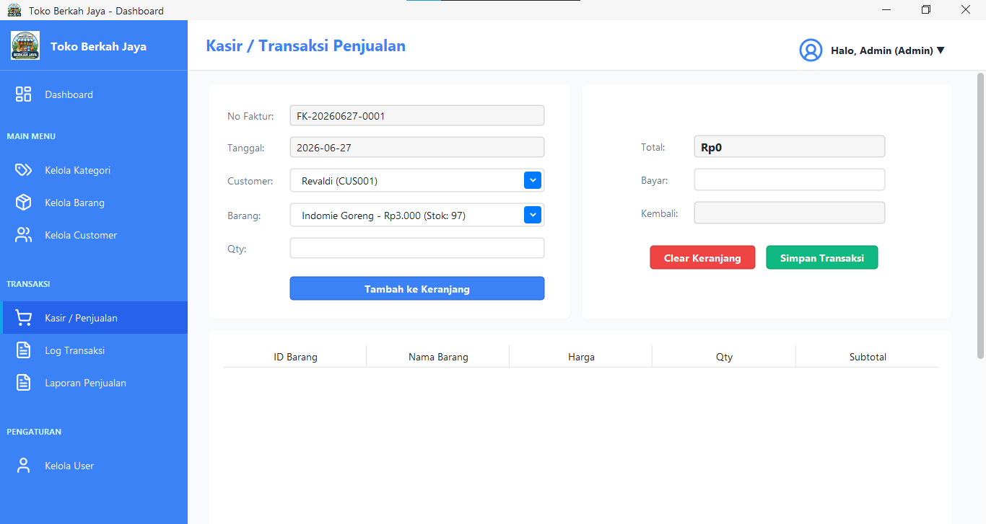

Nama Modul : Form InvoicePreviewDialog
Deskripsi : Dialog pratinjau invoice PDF untuk menampilkan detail transaksi penjualan sebelum dicetak.
package ui;

import ui.components.RoundedPanel;
import util.ThemeUtil;

import javax.swing.*;
import javax.swing.border.EmptyBorder;
import java.awt.*;
import java.awt.image.BufferedImage;
import java.io.File;

public class InvoicePreviewDialog extends JDialog {

private BufferedImage image;
private File pdfFile;
private util.ReceiptPrinter printer;

public InvoicePreviewDialog(JFrame parent, BufferedImage image, File pdfFile, util.ReceiptPrinter printer) {
super(parent, "Preview Faktur: " + pdfFile.getName(), true);
this.image = image;
this.pdfFile = pdfFile;
this.printer = printer;

initComponents();
setSize(400, 600);
setLocationRelativeTo(parent);
}

private void initComponents() {
setLayout(new BorderLayout(10, 10));
getContentPane().setBackground(ThemeUtil.BG_SOFT);

JPanel panelInfo = new JPanel(new FlowLayout(FlowLayout.CENTER));
panelInfo.setBackground(ThemeUtil.SUCCESS_COLOR);
JLabel lblInfo = new JLabel("Faktur telah otomatis tersimpan sebagai PDF!");
lblInfo.setForeground(Color.WHITE);
lblInfo.setFont(new Font("Segoe UI", Font.BOLD, 14));
panelInfo.add(lblInfo);
add(panelInfo, BorderLayout.NORTH);

JPanel panelCanvas = new JPanel(new GridBagLayout());
panelCanvas.setBackground(Color.DARK_GRAY);

JLabel lblImage = new JLabel(new ImageIcon(image.getScaledInstance(image.getWidth() / 2, image.getHeight() / 2, Image.SCALE_SMOOTH)));
lblImage.setBorder(BorderFactory.createLineBorder(Color.LIGHT_GRAY, 1));
panelCanvas.add(lblImage);

JScrollPane scroll = new JScrollPane(panelCanvas);
scroll.setBorder(null);
scroll.getVerticalScrollBar().setUnitIncrement(16);
add(scroll, BorderLayout.CENTER);

JPanel panelBtn = new JPanel(new FlowLayout(FlowLayout.RIGHT, 10, 10));
panelBtn.setOpaque(false);
panelBtn.setBorder(new EmptyBorder(5, 10, 10, 10));

JButton btnOpen = new JButton("Buka PDF");
ThemeUtil.styleButton(btnOpen, ThemeUtil.OCEAN_BLUE);
btnOpen.addActionListener(e -> {
try {
if (Desktop.isDesktopSupported()) {
Desktop.getDesktop().open(pdfFile);
}
} catch (Exception ex) {
JOptionPane.showMessageDialog(this, "Gagal membuka PDF: " + ex.getMessage());
}
});

JButton btnPrint = new JButton("Cetak Fisik");
ThemeUtil.styleButton(btnPrint, ThemeUtil.OCEAN_BLUE);
btnPrint.addActionListener(e -> {
try {
java.awt.print.PrinterJob pj = java.awt.print.PrinterJob.getPrinterJob();
pj.setPrintable(printer);
if (pj.printDialog()) {
pj.print();
}
} catch (Exception ex) {
JOptionPane.showMessageDialog(this, "Gagal mencetak: " + ex.getMessage());
}
});

JButton btnTutup = new JButton("Tutup");
ThemeUtil.styleButton(btnTutup, ThemeUtil.ERROR_COLOR);
btnTutup.addActionListener(e -> dispose());

panelBtn.add(btnOpen);
panelBtn.add(btnPrint);
panelBtn.add(btnTutup);

add(panelBtn, BorderLayout.SOUTH);
}
}
Hasil:

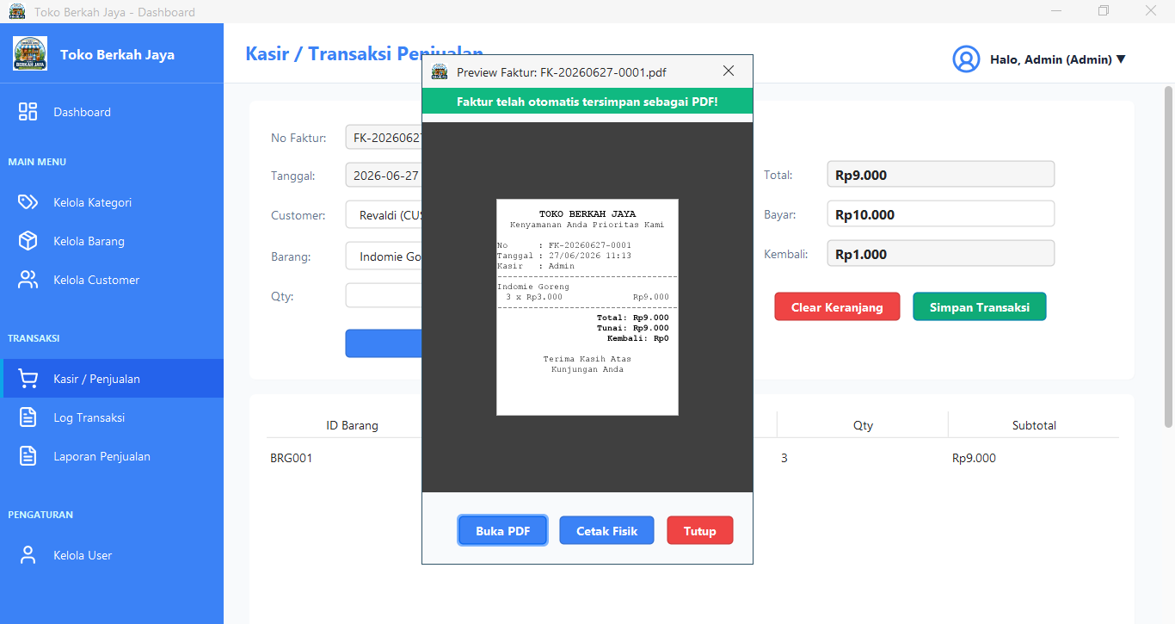

Nama Modul : Form LaporanForm
Deskripsi : Form laporan penjualan yang digunakan untuk melakukan filter data transaksi penjualan dan mengekspornya ke format Microsoft Excel (.xlsx).
package ui;

import service.LaporanService;
import service.KategoriService;
import service.CustomerService;
import ui.components.RoundedPanel;
import util.ThemeUtil;
import util.Formatter;

import javax.swing.*;
import javax.swing.border.EmptyBorder;
import javax.swing.table.DefaultTableModel;
import java.awt.*;
import java.io.File;
import java.io.FileOutputStream;
import java.text.SimpleDateFormat;
import java.util.Date;
import java.util.List;

import org.apache.poi.ss.usermodel.*;
import org.apache.poi.xssf.usermodel.XSSFWorkbook;

public class LaporanForm extends JPanel {

private LaporanService laporanService;
private KategoriService kategoriService;
private CustomerService customerService;

private DefaultTableModel tblModel;
private JTable tblLaporan;

private JTextField txtTglMulai, txtTglAkhir;
private JComboBox<String> cbKategori, cbCustomer;
private JLabel lblTotalPendapatan, lblTotalTransaksi;

public LaporanForm() {
laporanService = new LaporanService();
kategoriService = new KategoriService();
customerService = new CustomerService();

setLayout(new BorderLayout(20, 20));
setBackground(ThemeUtil.BG_SOFT);
setBorder(new EmptyBorder(20, 20, 20, 20));

initComponents();
loadDropdowns();
loadData();
}

private void initComponents() {

RoundedPanel pnlHeader = ThemeUtil.createCardPanel();
pnlHeader.setLayout(new BorderLayout(10, 10));

JLabel lblTitle = new JLabel("Laporan Penjualan");
lblTitle.setFont(new java.awt.Font("Segoe UI", java.awt.Font.BOLD, 22));
lblTitle.setForeground(ThemeUtil.TEXT_PRIMARY);
pnlHeader.add(lblTitle, BorderLayout.NORTH);

JPanel pnlFilter = new JPanel(new java.awt.GridLayout(2, 1, 0, 10));
pnlFilter.setOpaque(false);

JPanel pnlTop = new JPanel(new FlowLayout(FlowLayout.LEFT, 15, 0));
pnlTop.setOpaque(false);
pnlTop.add(new JLabel("Mulai (YYYY-MM-DD):"));
txtTglMulai = new JTextField(10);
ThemeUtil.styleTextField(txtTglMulai);
pnlTop.add(txtTglMulai);
pnlTop.add(new JLabel("Akhir (YYYY-MM-DD):"));
txtTglAkhir = new JTextField(10);
ThemeUtil.styleTextField(txtTglAkhir);
pnlTop.add(txtTglAkhir);
pnlFilter.add(pnlTop);

JPanel pnlBot = new JPanel(new FlowLayout(FlowLayout.LEFT, 15, 0));
pnlBot.setOpaque(false);
pnlBot.add(new JLabel("Kategori:"));
cbKategori = new JComboBox<>();
cbKategori.setPreferredSize(new java.awt.Dimension(180, 30));
pnlBot.add(cbKategori);

pnlBot.add(new JLabel("Customer:"));
cbCustomer = new JComboBox<>();
cbCustomer.setPreferredSize(new java.awt.Dimension(180, 30));
pnlBot.add(cbCustomer);

JButton btnFilter = new JButton("Terapkan Filter");
ThemeUtil.styleButton(btnFilter, ThemeUtil.OCEAN_BLUE);
btnFilter.addActionListener(e -> loadData());
pnlBot.add(btnFilter);
pnlFilter.add(pnlBot);

pnlHeader.add(pnlFilter, BorderLayout.CENTER);
add(pnlHeader, BorderLayout.NORTH);

RoundedPanel pnlTable = ThemeUtil.createCardPanel();
pnlTable.setLayout(new BorderLayout(10, 10));

String[] cols = {"Pilih", "No Faktur", "Tanggal", "Customer", "Kasir", "Total Bayar"};
tblModel = new DefaultTableModel(cols, 0) {
@Override
public Class<?> getColumnClass(int columnIndex) {
return columnIndex == 0 ? Boolean.class : super.getColumnClass(columnIndex);
}
@Override
public boolean isCellEditable(int row, int column) { return column == 0; }
};
tblLaporan = new JTable(tblModel);
JScrollPane sp = new JScrollPane(tblLaporan);
ThemeUtil.styleTable(tblLaporan, sp);
pnlTable.add(sp, BorderLayout.CENTER);

JPanel pnlFooter = new JPanel(new BorderLayout());
pnlFooter.setOpaque(false);
pnlFooter.setBorder(new EmptyBorder(10, 0, 0, 0));

JPanel pnlSummary = new JPanel(new FlowLayout(FlowLayout.LEFT, 20, 0));
pnlSummary.setOpaque(false);
lblTotalTransaksi = new JLabel("Total Transaksi: 0");
lblTotalTransaksi.setFont(ThemeUtil.FONT_BOLD);
lblTotalPendapatan = new JLabel("Total Pendapatan: Rp0");
lblTotalPendapatan.setFont(ThemeUtil.FONT_BOLD);
lblTotalPendapatan.setForeground(ThemeUtil.SUCCESS_COLOR);
pnlSummary.add(lblTotalTransaksi);
pnlSummary.add(lblTotalPendapatan);

JPanel pnlAction = new JPanel(new FlowLayout(FlowLayout.RIGHT, 10, 0));
pnlAction.setOpaque(false);

JButton btnExportExcel = new JButton("Export ke Excel");
ThemeUtil.styleButton(btnExportExcel, new java.awt.Color(33, 115, 70));
btnExportExcel.addActionListener(e -> exportToExcel());
pnlAction.add(btnExportExcel);

pnlFooter.add(pnlSummary, BorderLayout.WEST);
pnlFooter.add(pnlAction, BorderLayout.EAST);

pnlTable.add(pnlFooter, BorderLayout.SOUTH);
add(pnlTable, BorderLayout.CENTER);
}

private void loadDropdowns() {
cbKategori.addItem("Semua Kategori");
java.util.List<model.Kategori> kats = kategoriService.getAllKategori();
for (model.Kategori k : kats) {
cbKategori.addItem(k.getIdKategori() + " - " + k.getNamaKategori());
}
util.AutoCompletion.enable(cbKategori);

cbCustomer.addItem("Semua Customer");
java.util.List<model.Customer> custs = customerService.getAllCustomer();
for (model.Customer c : custs) {
cbCustomer.addItem(c.getIdCustomer() + " - " + c.getNamaCustomer());
}
util.AutoCompletion.enable(cbCustomer);
}

private void loadData() {
tblModel.setRowCount(0);

Date start = parseDate(txtTglMulai.getText());
Date end = parseDate(txtTglAkhir.getText());

String kat = cbKategori.getSelectedItem().toString();
String idKat = kat.equals("Semua Kategori") ? "Semua Kategori" : kat.split(" - ")[0];

String cus = cbCustomer.getSelectedItem().toString();
String idCus = cus.equals("Semua Customer") ? "Semua Customer" : cus.split(" - ")[0];

List<Object[]> data = laporanService.getLaporanRingkasan(start, end, idCus, idKat);

double totalPendapatan = 0;
for (Object[] row : data) {
totalPendapatan += (double) row[4];
row[4] = Formatter.formatRupiah((double) row[4]);
tblModel.addRow(new Object[]{true, row[0], row[1], row[2], row[3], row[4]});
}

lblTotalTransaksi.setText("Total Transaksi: " + data.size());
lblTotalPendapatan.setText("Total Pendapatan: " + Formatter.formatRupiah(totalPendapatan));
}

private Date parseDate(String text) {
if (text == null || text.trim().isEmpty()) return null;
try {
return new SimpleDateFormat("yyyy-MM-dd").parse(text);
} catch (Exception e) {
return null;
}
}

private void exportToExcel() {
try {
Date start = parseDate(txtTglMulai.getText());
Date end = parseDate(txtTglAkhir.getText());
String kat = cbKategori.getSelectedItem().toString();
String idKat = kat.equals("Semua Kategori") ? "Semua Kategori" : kat.split(" - ")[0];
String cus = cbCustomer.getSelectedItem().toString();
String idCus = cus.equals("Semua Customer") ? "Semua Customer" : cus.split(" - ")[0];

java.util.Set<String> selectedFaktur = new java.util.HashSet<>();
for (int i = 0; i < tblModel.getRowCount(); i++) {
Boolean isSelected = (Boolean) tblModel.getValueAt(i, 0);
if (isSelected != null && isSelected) {
selectedFaktur.add((String) tblModel.getValueAt(i, 1));
}
}

if (selectedFaktur.isEmpty()) {
javax.swing.JOptionPane.showMessageDialog(this, "Pilih minimal 1 transaksi untuk diekspor!", "Peringatan", javax.swing.JOptionPane.WARNING_MESSAGE);
return;
}

List<Object[]> details = laporanService.getLaporanDetail(start, end, idCus, idKat);

Workbook workbook = new XSSFWorkbook();
Sheet sheet = workbook.createSheet("Laporan Penjualan");

CellStyle headerStyle = workbook.createCellStyle();
org.apache.poi.ss.usermodel.Font headerFont = workbook.createFont();
headerFont.setBold(true);
headerStyle.setFont(headerFont);

Row headerRow = sheet.createRow(0);
String[] headers = {"No Faktur", "Tanggal", "Customer", "Nama Barang", "Kategori", "Harga Satuan", "Qty", "Subtotal"};
for (int i = 0; i < headers.length; i++) {
Cell cell = headerRow.createCell(i);
cell.setCellValue(headers[i]);
cell.setCellStyle(headerStyle);
}

int rowNum = 1;
double grandTotal = 0;
for (Object[] row : details) {
if (!selectedFaktur.contains(row[0].toString())) continue;

Row r = sheet.createRow(rowNum++);
r.createCell(0).setCellValue(row[0].toString());
r.createCell(1).setCellValue(row[1].toString());
r.createCell(2).setCellValue(row[2].toString());
r.createCell(3).setCellValue(row[3].toString());
r.createCell(4).setCellValue(row[4].toString());
r.createCell(5).setCellValue((Double) row[5]);
r.createCell(6).setCellValue((Integer) row[6]);
r.createCell(7).setCellValue((Double) row[7]);
grandTotal += (Double) row[7];
}

Row totalRow = sheet.createRow(rowNum + 1);
Cell totalLabel = totalRow.createCell(6);
totalLabel.setCellValue("GRAND TOTAL:");
totalLabel.setCellStyle(headerStyle);

Cell totalValue = totalRow.createCell(7);
totalValue.setCellValue(grandTotal);
totalValue.setCellStyle(headerStyle);

for (int i = 0; i < headers.length; i++) {
sheet.autoSizeColumn(i);
}

String home = System.getProperty("user.home");
File file = new File(home + "/Downloads/Laporan_Penjualan_" + System.currentTimeMillis() + ".xlsx");

try (FileOutputStream fos = new FileOutputStream(file)) {
workbook.write(fos);
}
workbook.close();

javax.swing.JOptionPane.showMessageDialog(this, "Berhasil! Tersimpan di " + file.getAbsolutePath(), "Sukses", javax.swing.JOptionPane.INFORMATION_MESSAGE);

Desktop.getDesktop().open(file);

} catch (Exception ex) {
ex.printStackTrace();
javax.swing.JOptionPane.showMessageDialog(this, "Gagal export ke Excel: " + ex.getMessage(), "Error", javax.swing.JOptionPane.ERROR_MESSAGE);
}
}
}
Hasil:

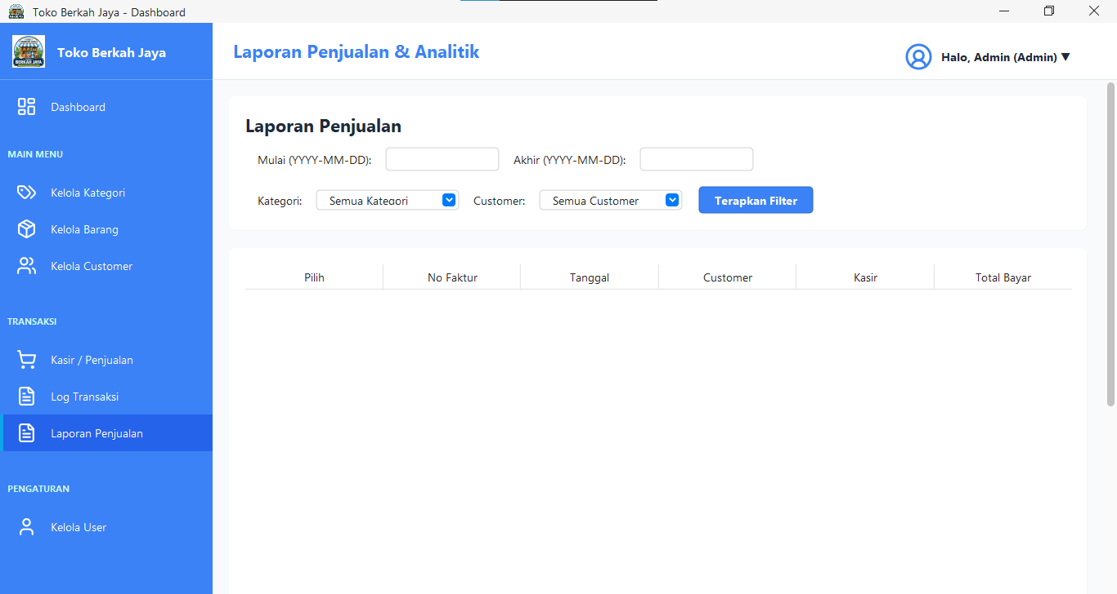

Nama Modul : Form LogTransaksiForm
Deskripsi : Form riwayat log transaksi penjualan yang digunakan untuk melacak riwayat transaksi di toko.
package ui;

import service.LogTransaksiService;
import util.ThemeUtil;
import util.Formatter;
import util.ReceiptPrinter;
import ui.components.RoundedPanel;

import javax.swing.*;
import javax.swing.border.EmptyBorder;
import javax.swing.table.DefaultTableModel;
import java.awt.*;
import java.awt.print.PrinterJob;
import java.util.List;
import java.util.Map;
import java.text.SimpleDateFormat;

public class LogTransaksiForm extends JPanel {
private JTable tableLog;
private DefaultTableModel tableModel;
private JComboBox<Integer> comboLimit;
private JLabel lblPageInfo;
private JButton btnPrev;
private JButton btnNext;
private JButton btnCetak;

private LogTransaksiService service;
private int currentPage = 1;
private int totalPages = 1;
private int limit = 10;

public LogTransaksiForm() {
this.service = new LogTransaksiService();
setLayout(new BorderLayout(15, 15));
setBackground(ThemeUtil.BG_SOFT);
setBorder(new EmptyBorder(20, 20, 20, 20));

initUI();
loadData();
}

private void initUI() {

JPanel headerPanel = new JPanel(new BorderLayout());
headerPanel.setOpaque(false);

btnCetak = new JButton("Cetak Ulang Faktur");
btnCetak.setFont(new Font("Segoe UI", Font.BOLD, 14));
btnCetak.setBackground(ThemeUtil.OCEAN_BLUE);
btnCetak.setForeground(Color.WHITE);
btnCetak.setFocusPainted(false);
btnCetak.setEnabled(false);
btnCetak.addActionListener(e -> cetakUlang());
headerPanel.add(btnCetak, BorderLayout.EAST);

add(headerPanel, BorderLayout.NORTH);

String[] columns = {"No Faktur", "Tanggal", "Total", "Bayar", "Kembali", "Kasir"};
tableModel = new DefaultTableModel(columns, 0) {
@Override
public boolean isCellEditable(int row, int column) {
return false;
}
};
tableLog = new JTable(tableModel);
tableLog.setFont(new Font("Segoe UI", Font.PLAIN, 14));
tableLog.setRowHeight(30);
tableLog.getTableHeader().setFont(new Font("Segoe UI", Font.BOLD, 14));
tableLog.getTableHeader().setBackground(ThemeUtil.OCEAN_BLUE);
tableLog.getTableHeader().setForeground(Color.WHITE);
tableLog.setSelectionMode(ListSelectionModel.SINGLE_SELECTION);
tableLog.getSelectionModel().addListSelectionListener(e -> {
btnCetak.setEnabled(tableLog.getSelectedRow() != -1);
});

JScrollPane scrollPane = new JScrollPane(tableLog);
scrollPane.setBorder(BorderFactory.createLineBorder(ThemeUtil.BORDER_COLOR));

RoundedPanel cardPanel = new RoundedPanel(15, Color.WHITE);
cardPanel.setLayout(new BorderLayout());
cardPanel.setBorder(new EmptyBorder(10, 10, 10, 10));
cardPanel.add(scrollPane, BorderLayout.CENTER);

add(cardPanel, BorderLayout.CENTER);

JPanel paginationPanel = new JPanel(new FlowLayout(FlowLayout.CENTER, 15, 10));
paginationPanel.setOpaque(false);

paginationPanel.add(new JLabel("Tampilkan:"));
comboLimit = new JComboBox<>(new Integer[]{10, 25, 50, 100});
comboLimit.setFont(new Font("Segoe UI", Font.PLAIN, 14));
comboLimit.addActionListener(e -> {
limit = (int) comboLimit.getSelectedItem();
currentPage = 1;
loadData();
});
paginationPanel.add(comboLimit);

btnPrev = new JButton("< Prev");
btnPrev.setFont(new Font("Segoe UI", Font.BOLD, 14));
btnPrev.addActionListener(e -> {
if (currentPage > 1) {
currentPage--;
loadData();
}
});
paginationPanel.add(btnPrev);

lblPageInfo = new JLabel("Halaman 1 dari 1");
lblPageInfo.setFont(new Font("Segoe UI", Font.BOLD, 14));
paginationPanel.add(lblPageInfo);

btnNext = new JButton("Next >");
btnNext.setFont(new Font("Segoe UI", Font.BOLD, 14));
btnNext.addActionListener(e -> {
if (currentPage < totalPages) {
currentPage++;
loadData();
}
});
paginationPanel.add(btnNext);

add(paginationPanel, BorderLayout.SOUTH);
}

public void loadData() {
int totalRows = service.getTotalTransactionsCount();
totalPages = (int) Math.ceil((double) totalRows / limit);
if (totalPages == 0) totalPages = 1;

int offset = (currentPage - 1) * limit;
List<Map<String, Object>> logs = service.getTransactionsLog(limit, offset);

tableModel.setRowCount(0);
SimpleDateFormat sdf = new SimpleDateFormat("dd-MM-yyyy HH:mm");
for (Map<String, Object> log : logs) {
tableModel.addRow(new Object[]{
log.get("no_faktur"),
sdf.format(log.get("tanggal")),
Formatter.formatRupiah((double) log.get("total")),
Formatter.formatRupiah((double) log.get("bayar")),
Formatter.formatRupiah((double) log.get("kembali")),
log.get("kasir")
});
}

lblPageInfo.setText("Halaman " + currentPage + " dari " + totalPages);
btnPrev.setEnabled(currentPage > 1);
btnNext.setEnabled(currentPage < totalPages);
btnCetak.setEnabled(false);
}

private void cetakUlang() {
int selectedRow = tableLog.getSelectedRow();
if (selectedRow == -1) return;

String noFaktur = (String) tableModel.getValueAt(selectedRow, 0);
Map<String, Object> header = service.getTransactionHeader(noFaktur);
List<Map<String, Object>> details = service.getTransactionDetails(noFaktur);

if (header != null && !details.isEmpty()) {
try {
util.ReceiptPrinter printer = new util.ReceiptPrinter(header, details);
java.awt.image.BufferedImage img = util.PdfGenerator.createReceiptImage(printer, details.size());
java.io.File pdfFile = util.PdfGenerator.saveAsPdf(img, noFaktur);

InvoicePreviewDialog dialog = new InvoicePreviewDialog((JFrame) SwingUtilities.getWindowAncestor(this), img, pdfFile, printer);
dialog.setVisible(true);
} catch (Exception ex) {
JOptionPane.showMessageDialog(this, "Gagal memuat pratinjau faktur: " + ex.getMessage(), "Error", JOptionPane.ERROR_MESSAGE);
ex.printStackTrace();
}
} else {
JOptionPane.showMessageDialog(this, "Data transaksi tidak lengkap!", "Error", JOptionPane.ERROR_MESSAGE);
}
}
}
Hasil:

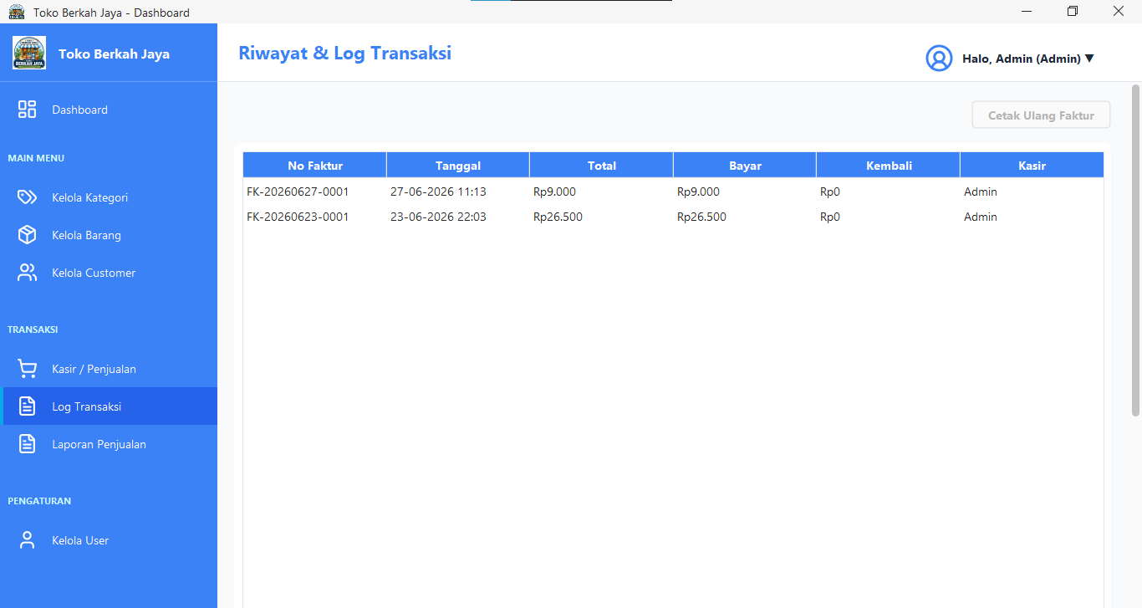

Nama Modul : Form ProfilForm
Deskripsi : Form profil pengguna yang digunakan untuk menampilkan dan memperbarui informasi akun user yang sedang aktif.
package ui;

import model.User;
import service.UserService;
import ui.components.Toast;

import javax.swing.*;
import javax.swing.border.EmptyBorder;
import util.ThemeUtil;
import util.ValidationUtil;
import ui.components.RoundedPanel;
import java.awt.*;
import java.awt.event.ActionListener;

public class ProfilForm extends JPanel {

private JTextField txtUsername, txtNamaLengkap;
private JPasswordField txtPasswordLama, txtPasswordBaru, txtKonfirmasiPassword;
private JButton btnSimpan;
private UserService service;
private User currentUser;
private Runnable onUpdate;

public ProfilForm(User user, Runnable onUpdate) {
this.currentUser = user;
this.onUpdate = onUpdate;
service = new UserService();
setLayout(new BorderLayout(20, 20));
setBackground(ThemeUtil.BG_SOFT);
setBorder(new EmptyBorder(20, 30, 20, 30));
initComponents();
loadData();
}

private void initComponents() {

RoundedPanel panelTop = ThemeUtil.createCardPanel();
panelTop.setLayout(new BorderLayout(10, 10));

JPanel panelInput = new JPanel(new GridBagLayout());
panelInput.setOpaque(false);
GridBagConstraints gbc = new GridBagConstraints();
gbc.insets = new Insets(8, 5, 8, 15);
gbc.fill = GridBagConstraints.HORIZONTAL;
gbc.anchor = GridBagConstraints.WEST;

gbc.gridx = 0; gbc.gridy = 0;
addLabel(panelInput, "Username:", gbc);
txtUsername = new JTextField(20);
ThemeUtil.styleTextField(txtUsername);
txtUsername.setEditable(false);
gbc.gridx = 1; panelInput.add(txtUsername, gbc);

gbc.gridx = 0; gbc.gridy = 1;
addLabel(panelInput, "Nama Lengkap:", gbc);
txtNamaLengkap = new JTextField(20);
ThemeUtil.styleTextField(txtNamaLengkap);
ValidationUtil.addAlphabetValidation(txtNamaLengkap);
gbc.gridx = 1; panelInput.add(txtNamaLengkap, gbc);

gbc.gridx = 0; gbc.gridy = 2;
addLabel(panelInput, "Password Lama:", gbc);
txtPasswordLama = new JPasswordField(20);
ThemeUtil.stylePasswordField(txtPasswordLama);
gbc.gridx = 1; panelInput.add(txtPasswordLama, gbc);

gbc.gridx = 0; gbc.gridy = 3;
addLabel(panelInput, "Password Baru:", gbc);
txtPasswordBaru = new JPasswordField(20);
ThemeUtil.stylePasswordField(txtPasswordBaru);
gbc.gridx = 1; panelInput.add(txtPasswordBaru, gbc);

gbc.gridx = 0; gbc.gridy = 4;
addLabel(panelInput, "Konfirmasi Password:", gbc);
txtKonfirmasiPassword = new JPasswordField(20);
ThemeUtil.stylePasswordField(txtKonfirmasiPassword);
gbc.gridx = 1; panelInput.add(txtKonfirmasiPassword, gbc);

gbc.gridx = 1; gbc.gridy = 5;
JCheckBox chkShowPassword = new JCheckBox("Tampilkan Password");
chkShowPassword.setOpaque(false);
chkShowPassword.setFont(ThemeUtil.FONT_REGULAR);
chkShowPassword.setForeground(ThemeUtil.TEXT_SECONDARY);
chkShowPassword.addItemListener(e -> {
char echoChar = chkShowPassword.isSelected() ? (char) 0 : '\u2022';
txtPasswordLama.setEchoChar(echoChar);
txtPasswordBaru.setEchoChar(echoChar);
txtKonfirmasiPassword.setEchoChar(echoChar);
});
panelInput.add(chkShowPassword, gbc);

JPanel panelBtn = new JPanel(new FlowLayout(FlowLayout.LEFT, 10, 0));
panelBtn.setOpaque(false);
btnSimpan = new JButton("Update Profil");
ThemeUtil.styleButton(btnSimpan, ThemeUtil.OCEAN_BLUE);

panelBtn.add(btnSimpan);

panelTop.add(panelInput, BorderLayout.WEST);
panelTop.add(panelBtn, BorderLayout.SOUTH);

JPanel wrapper = new JPanel(new BorderLayout());
wrapper.setOpaque(false);
wrapper.add(panelTop, BorderLayout.NORTH);

add(wrapper, BorderLayout.CENTER);

btnSimpan.addActionListener(e -> updateProfil());

ActionListener enterSubmit = e -> btnSimpan.doClick();
txtNamaLengkap.addActionListener(enterSubmit);
txtPasswordLama.addActionListener(enterSubmit);
txtPasswordBaru.addActionListener(enterSubmit);
txtKonfirmasiPassword.addActionListener(enterSubmit);
}

private void addLabel(JPanel p, String text, GridBagConstraints gbc) {
JLabel lbl = new JLabel(text);
lbl.setFont(ThemeUtil.FONT_REGULAR);
lbl.setForeground(ThemeUtil.TEXT_SECONDARY);
p.add(lbl, gbc);
}

private void loadData() {
if (currentUser != null) {
txtUsername.setText(currentUser.getUsername());
txtNamaLengkap.setText(currentUser.getNamaLengkap());
}
}

private void updateProfil() {
if (currentUser == null) return;

String namaBaru = txtNamaLengkap.getText().trim();
String passLama = new String(txtPasswordLama.getPassword());
String passBaru = new String(txtPasswordBaru.getPassword());
String confPass = new String(txtKonfirmasiPassword.getPassword());

if (namaBaru.isEmpty()) {
Toast.showError((JFrame) SwingUtilities.getWindowAncestor(this), "Nama Lengkap tidak boleh kosong");
return;
}

String passwordToSave = currentUser.getPassword();

if (!passLama.isEmpty() || !passBaru.isEmpty() || !confPass.isEmpty()) {
if (!passLama.equals(currentUser.getPassword())) {
Toast.showError((JFrame) SwingUtilities.getWindowAncestor(this), "Password Lama salah!");
return;
}
if (passBaru.length() < 6) {
Toast.showError((JFrame) SwingUtilities.getWindowAncestor(this), "Password Baru minimal 6 karakter!");
return;
}
if (!passBaru.equals(confPass)) {
Toast.showError((JFrame) SwingUtilities.getWindowAncestor(this), "Konfirmasi Password tidak cocok!");
return;
}
passwordToSave = passBaru;
}

currentUser.setNamaLengkap(namaBaru);
currentUser.setPassword(passwordToSave);

if (service.updateUser(currentUser)) {
Toast.showSuccess((JFrame) SwingUtilities.getWindowAncestor(this), "Profil berhasil diupdate!");
txtPasswordLama.setText("");
txtPasswordBaru.setText("");
txtKonfirmasiPassword.setText("");
if (onUpdate != null) {
onUpdate.run();
}
} else {
Toast.showError((JFrame) SwingUtilities.getWindowAncestor(this), "Gagal mengupdate profil!");
}
}
}
Hasil:

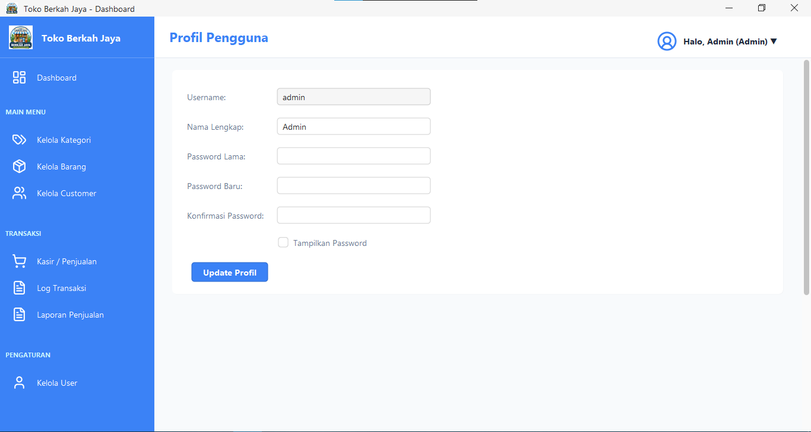

- Komponen Pre Exiting
Dalam pengembangan Aplikasi Kasir Toko Berkah Jaya, beberapa pustaka pihak ketiga (pre-existing components) digunakan untuk mendukung fungsionalitas aplikasi, yaitu:
- FlatLaf (Look and Feel), digunakan sebagai pustaka antarmuka Java Swing untuk menghasilkan tampilan aplikasi yang modern serta mendukung tema light mode dan dark mode.
- Apache POI, digunakan untuk membuat dan mengekspor laporan penjualan ke dalam format Microsoft Excel (.xlsx).
- MySQL Connector/J (JDBC), digunakan sebagai driver yang menghubungkan aplikasi Java dengan basis data MySQL sehingga proses pertukaran data dapat dilakukan melalui JDBC.

BAB III. Lingkungan Pengujian Perangkat Lunak
- Perangkat Lunak Pengujian
- Sistem Operasi : Windows 10
- Bahasa Pemrograman : Java
- Database : MySQL (XAMPP Server)

- Perangkat Keras Pengujian
- Processor : Intel(R) Celeron(R) CPU 3867U @ 1.80 GHz
- Memory : 8 GB RAM
- Harddisk : 1 TB HDD

- Material Pengujian
Proses pengujian dilakukan secara bertahap untuk memastikan seluruh fungsi aplikasi berjalan sesuai kebutuhan. Tahapan pengujian yang dilakukan meliputi:
- Menjalankan layanan Apache dan MySQL melalui XAMPP, kemudian memastikan basis data tokoberkahjaya telah berhasil diimpor.
- Menjalankan aplikasi kasir melalui Apache NetBeans atau berkas JAR hasil kompilasi.
- Menguji fitur login menggunakan akun Admin dan Kasir untuk memverifikasi hak akses masing-masing pengguna.
- Menguji fungsi CRUD pada data barang, kategori, customer, dan pengguna.
- Melakukan simulasi transaksi penjualan, mulai dari pemilihan barang, pengaturan jumlah pembelian, pemilihan customer, perhitungan pembayaran, pencetakan struk, hingga pratinjau invoice dalam format PDF.
- Memastikan setiap transaksi yang berhasil diproses tercatat pada log aktivitas dan perubahan stok barang.
- Menguji fitur laporan dengan menerapkan filter data, kemudian mengekspor hasilnya ke dalam berkas Microsoft Excel (.xlsx) untuk memastikan data tersimpan dengan benar.

- Sumber Daya Manusia
Pelaksanaan pengujian perangkat lunak melibatkan beberapa pihak sesuai dengan perannya, yaitu:
- Pengembang / Tester Utama, yaitu Revaldi Winata, yang bertanggung jawab menyusun skenario pengujian serta melakukan pengujian fungsional aplikasi.
- Kasir Toko (End-user), yang melakukan simulasi transaksi penjualan untuk memastikan proses operasional berjalan dengan baik.
- Pemilik Toko / Admin, yang menguji pengelolaan data master serta memverifikasi laporan penjualan yang dihasilkan sistem.

- Prosedur Umum Pengujian
- Rencana Pengujian
Rencana pengujian menggunakan metode Black-Box Testing berfokus pada fungsionalitas luar sistem tanpa menguji alur logika internal kode program. Berikut adalah tabel rencana pengujian Alpha untuk aplikasi sesuai format kolom pada template:
Tabel 3
Rencana Pengujian Alpha Aplikasi Sistem Toko Berkah Jaya
Kelas Uji | Butir uji | Jenis Pengujian
Login | Verifikasi masuk dan pemisahan hak akses | Black box
Pengaturan login | Validasi password lama | Black box
 | Ganti password
Pendaftaran Pengguna | Tambah data pengguna | Black box
 | Ubah data pengguna
Kelola Kategori & Barang | CRUD Kategori Produk | Black box
 | CRUD Data Barang
Kelola Pelanggan (Customer) | CRUD data customer / pelanggan toko | Black box
Transaksi Kasir | Input barang belanjaan, hitung total, diskon, bayar, & kembalian | Black box
Laporan Penjualan | Ekspor laporan penjualan ke berkas Microsoft Excel (.xlsx) | Black box

2. Implementasi Pengujian
Tabel 4 Pengujian Login
Deskripsi: Pengujian Form Login
Prosedur: Memasukkan Username dan Password pada field yang tersedia
Data Masukkan : Username dan Password
Kasus dan hasil uji ( data Normal )
Keluaran yang diharapkan | Data login dimasukkan, isi username dan isi password lalu klik tombol login maka dilakukan proses pengecekan data login. Apabila data login benar maka masuk ke menu masing-masing pengguna.
Kriteria Evaluasi | Dapat mengisi data login sesuai dengan yang diharapkan.
Hasil | Sukses
kesimpulan | Diterima
Kasus dan hasil uji ( data salah )
Keluaran yang diharapkan | Data login tidak terdaftar dan menampilkan pesan Kesalahan.
Kriteria Evaluasi | User tidak bisa melakukan login, menampilkan pesan, sesuai dengan yang diharapkan.
Hasil | Sukses
kesimpulan | Diterima

Tabel 5 Pengujian CRUD Barang & Stok
Deskripsi: Pengujian CRUD Data Barang
Prosedur: Menginput ID barang, nama barang, kategori, satuan, harga jual, dan stok awal lalu mengeklik tombol simpan
Data Masukkan : Data barang baru lengkap
Kasus dan hasil uji ( data Normal )
Keluaran yang diharapkan | Data barang diisi lengkap, klik tombol simpan, data berhasil tersimpan ke database MySQL dan muncul di tabel GUI.
Kriteria Evaluasi | Data masuk ke database secara lengkap dan presisi tanpa ada kolom kosong.
Hasil | Sukses
kesimpulan | Diterima
Kasus dan hasil uji ( data salah )
Keluaran yang diharapkan | Nama barang atau harga diinput kosong/tidak valid lalu klik simpan, sistem menolak menyimpan dan menampilkan pesan kesalahan.
Kriteria Evaluasi | Validasi input mencegah penyimpanan data kosong atau tidak valid di database.
Hasil | Sukses
kesimpulan | Diterima

Tabel 6 Pengujian Transaksi Penjualan (Kasir)
Deskripsi: Pengujian Transaksi Penjualan Kasir
Prosedur: Memasukkan barang ke keranjang belanja, menginput nominal uang bayar, dan menekan tombol bayar
Data Masukkan : ID Barang, jumlah beli, uang tunai pelanggan
Kasus dan hasil uji ( data Normal )
Keluaran yang diharapkan | Barang masuk keranjang, total harga terhitung otomatis. Pembayaran diproses, struk penjualan terbit, dan stok barang berkurang otomatis di database.
Kriteria Evaluasi | Perhitungan total belanja, diskon, kembalian akurat, serta struk tercetak dengan benar.
Hasil | Sukses
kesimpulan | Diterima
Kasus dan hasil uji ( data salah )
Keluaran yang diharapkan | Nominal uang bayar diinput kurang dari total belanja, lalu klik proses. Sistem memblokir transaksi dan menampilkan pesan peringatan.
Kriteria Evaluasi | Kasir tidak bisa memproses transaksi jika pembayaran kurang.
Hasil | Sukses
kesimpulan | Diterima

Tabel 7 Pengujian Ekspor Laporan Excel
Deskripsi: Pengujian Ekspor Laporan Excel
Prosedur: Memilih filter rentang waktu transaksi, kategori, atau nama customer kemudian mengeklik tombol ekspor Excel
Data Masukkan : Filter rentang tanggal, pelanggan, kategori
Kasus dan hasil uji ( data Normal )
Keluaran yang diharapkan | Menekan tombol ekspor Excel, data laporan penjualan yang sesuai langsung tertulis ke berkas format Excel (.xlsx).
Kriteria Evaluasi | Berkas Excel berhasil terbuat, sel data transaksi cocok dengan database, dan dapat dibuka dengan normal.
Hasil | Sukses
kesimpulan | Diterima
Kasus dan hasil uji ( data salah )
Keluaran yang diharapkan | Memilih filter tanggal di mana tidak ada transaksi terdaftar, lalu klik ekspor Excel. Sistem mengekspor file kosong/hanya header dan menampilkan pesan.
Kriteria Evaluasi | File terbuat sesuai filter kosong tanpa error/crash pada aplikasi.
Hasil | Sukses
kesimpulan | Diterima

3. Kesimpulan Hasil Uji
. Berdasarkan pengujian alpha menggunakan metode Black-Box Testing terhadap seluruh modul utama, meliputi Login, CRUD data master (Barang, Kategori, Customer, dan User), Transaksi Penjualan, Log Transaksi, serta Ekspor Laporan Excel, dapat disimpulkan bahwa seluruh fungsi aplikasi berjalan sesuai dengan kebutuhan. Setiap modul menghasilkan keluaran yang diharapkan dan selama proses pengujian tidak ditemukan kegagalan sistem (crash) maupun kesalahan fungsional.
4. Laporan Pengujian
- Ringkasan Hasil
Pengujian telah dilakukan pada seluruh skenario yang direncanakan. Hasilnya menunjukkan bahwa semua butir pengujian berhasil dijalankan dengan status Sukses dan Diterima, sehingga tingkat keberhasilan fungsionalitas aplikasi mencapai 100%.
- Evaluasi
Mekanisme validasi masukan telah berfungsi dengan baik dalam mencegah data yang tidak valid, seperti kolom yang kosong, nilai harga yang tidak sesuai format, maupun nominal pembayaran yang lebih kecil dari total transaksi. Selain itu, antarmuka berbasis FlatLaf dapat berjalan dengan stabil dan navigasi antar menu berlangsung dengan responsif.
- Rekomendasi
Sebagai pengembangan berikutnya, aplikasi disarankan dilengkapi dengan fitur pencadangan (backup) basis data secara otomatis atau langsung melalui aplikasi desktop agar keamanan data transaksi tetap terjaga apabila terjadi gangguan pada server MySQL lokal.

BAB III. Penutup
- Kesimpulan
Berdasarkan proses analisis, perancangan, implementasi, dan pengujian yang telah dilakukan, dapat disimpulkan bahwa Aplikasi Kasir Toko Berkah Jaya berhasil dikembangkan sebagai sistem Point of Sales (POS) berbasis desktop menggunakan Java, Apache NetBeans, dan MySQL. Aplikasi ini mampu mendukung proses transaksi penjualan, pengelolaan data master, serta penyusunan laporan secara lebih efektif dibandingkan pencatatan manual.
Hasil pengujian menggunakan metode Black-Box Testing menunjukkan bahwa seluruh fitur utama aplikasi, meliputi autentikasi pengguna, pengelolaan data master, transaksi penjualan, pencatatan log aktivitas, hingga ekspor laporan penjualan ke Microsoft Excel, dapat berfungsi sesuai dengan kebutuhan tanpa ditemukan kesalahan yang memengaruhi proses operasional. Selain itu, penggunaan Apache POI mempermudah pembuatan laporan dalam format .xlsx, sedangkan FlatLaf memberikan tampilan antarmuka yang lebih modern dan nyaman digunakan.

- Saran
Meskipun aplikasi telah memenuhi kebutuhan operasional dasar, masih terdapat beberapa pengembangan yang dapat dilakukan untuk meningkatkan kualitas sistem, antara lain:
- Menambahkan mekanisme enkripsi kata sandi menggunakan algoritma seperti BCrypt atau SHA-256 untuk meningkatkan keamanan data pengguna.
- Mengembangkan fitur backup dan restore basis data secara otomatis guna meminimalkan risiko kehilangan data akibat gangguan pada server database.
- Menambahkan dukungan pembayaran non-tunai, seperti QRIS, e-wallet, atau debit card reader, agar proses transaksi menjadi lebih fleksibel.
- Mengembangkan fitur pemantauan stok yang dapat memberikan notifikasi ketika jumlah persediaan mencapai batas minimum sehingga proses pengadaan barang dapat dilakukan lebih cepat.

